CRM APPLICATION THAT HELPS TO BOOK A VISA SLOT

1. **INTRODUCTION** 
   1. **Overview**

In this project, we use custom objects, relationships, page layouts to give CRM Application that helps to book a visa slot by easy access to data that people had book visa slot easily to book an visa slot by using CRM application

**1.2 Purpose**

A visa slot management project is a system that is used to track and manage the availability of visa slots, which are appointments that are required for certain visa applications. It might be used by a government agency or a visa processing center to schedule and manage appointments with applicants.

**2 Problem Definition & Design Thinking**

**2.1Empathy Map**

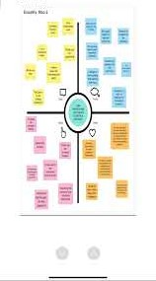

**2.2Ideation & Brainstorming Map**

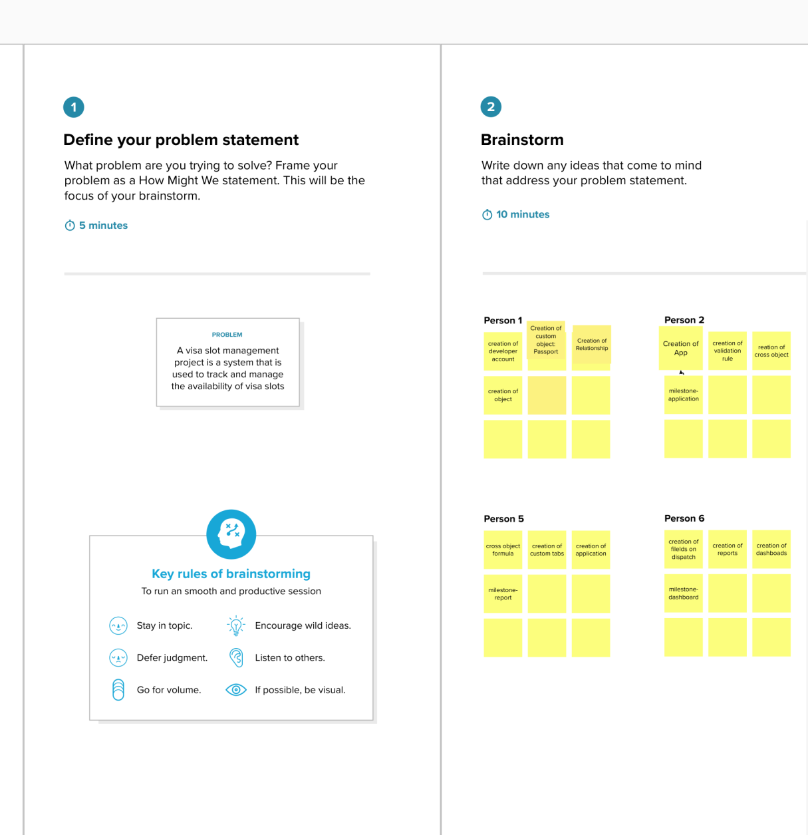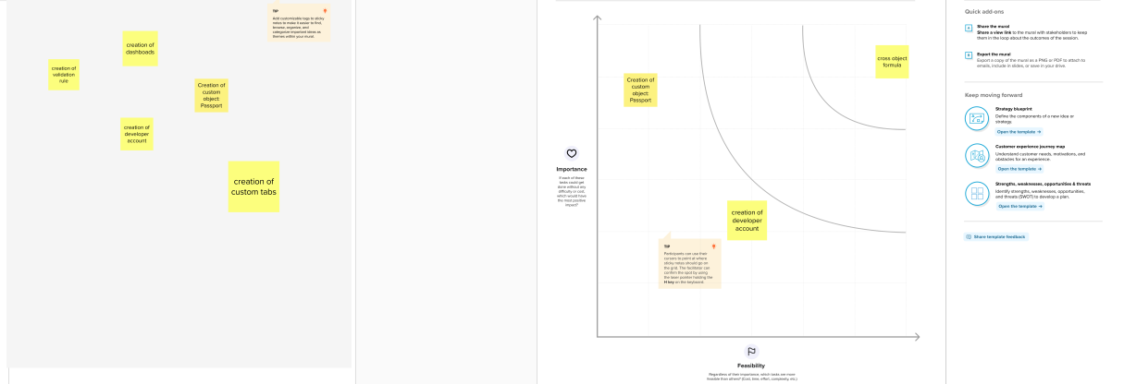

1. **RESULT**

**3.1 Data Model:**

|  |  |
| --- | --- |
| **Object name** | **Fields in the Object** |
| Passport | |  |  | | --- | --- | | Field label | Data type | | Contact Number | Number | | Full Name | Text | | Passport Number | Text | | Permanent Address | Text | |
| Visa Slot | |  |  | | --- | --- | | Field label | Data type | | Location | Geolocation | | Time | Time | | Passport Number | Master-detail relationship | | Visa Slot Number | Master-detail relationship | |
| Payement | |  |  | | --- | --- | | Field label | Data type | | Payment Mode | Geolocation | | Card Number | Time | | Transation ID | Number | | Cancel Transaction | Operation | | Visa Slot Number | Master-detail relationship | |
| Reschedule/Cancel | |  |  | | --- | --- | | Field label | Data type | | Passport Number | Master-detail relationship | | Location | Geolocation | | Time | Time | | Cancel | Operation | | Status | Lookup relationship | |

**3.2Activity & Screenshot**



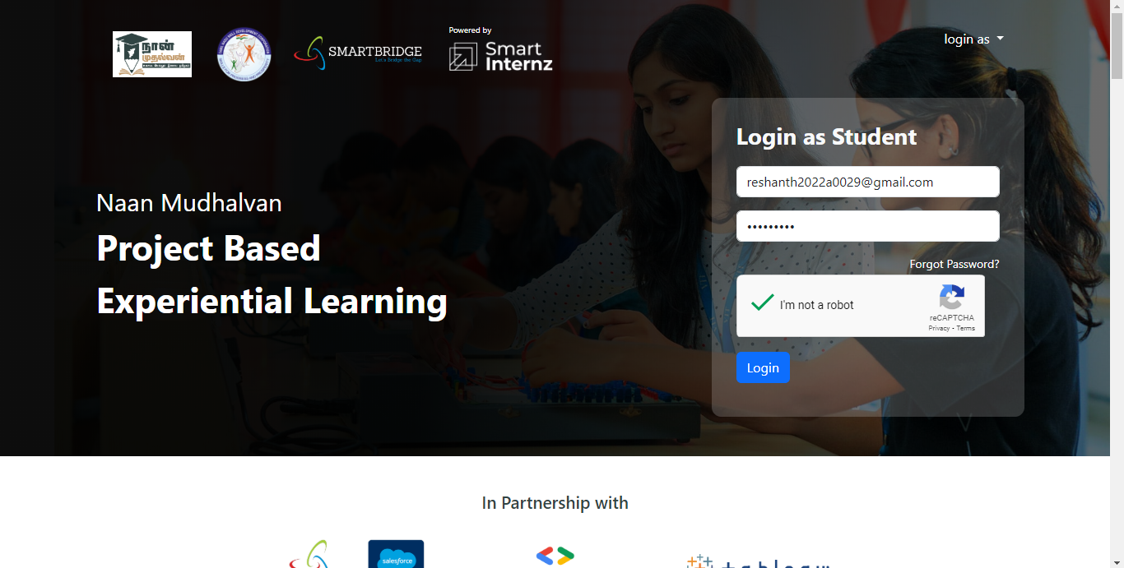

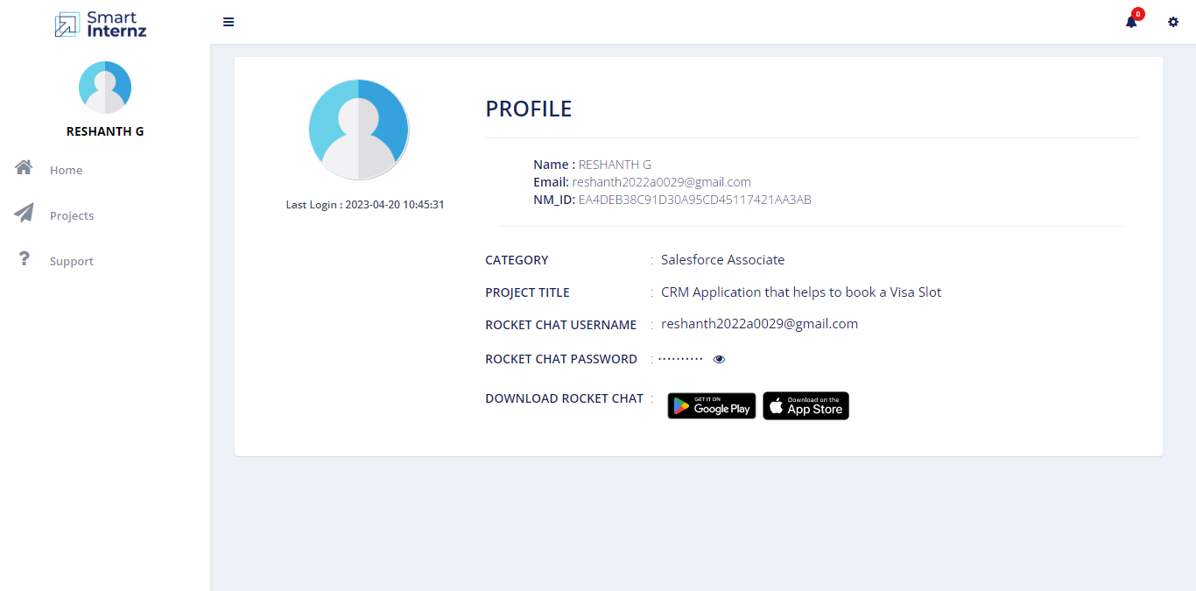

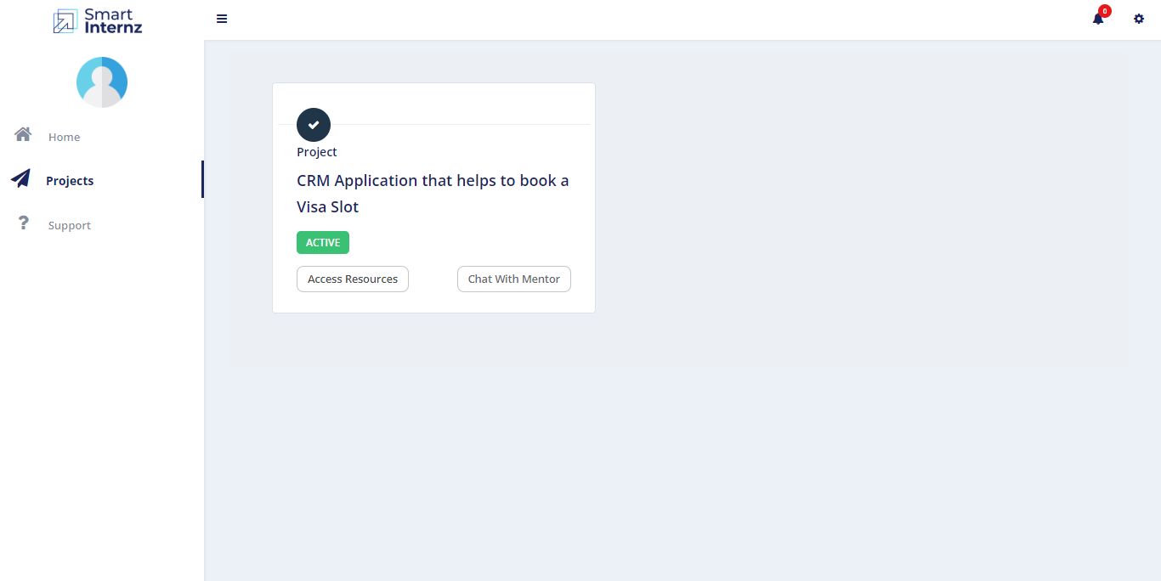

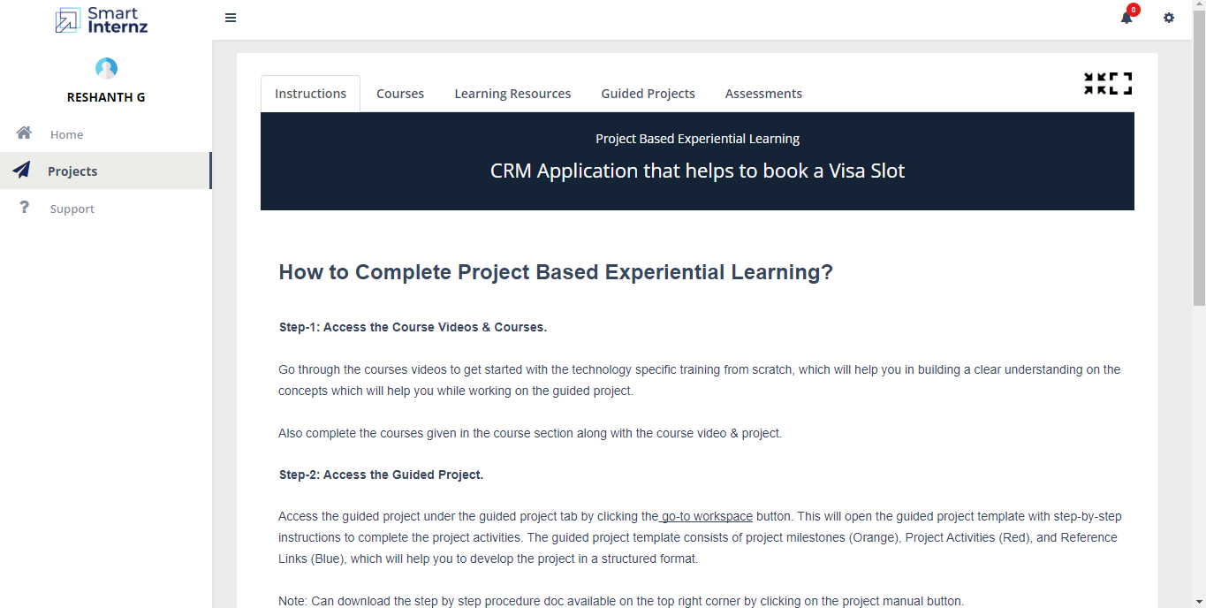

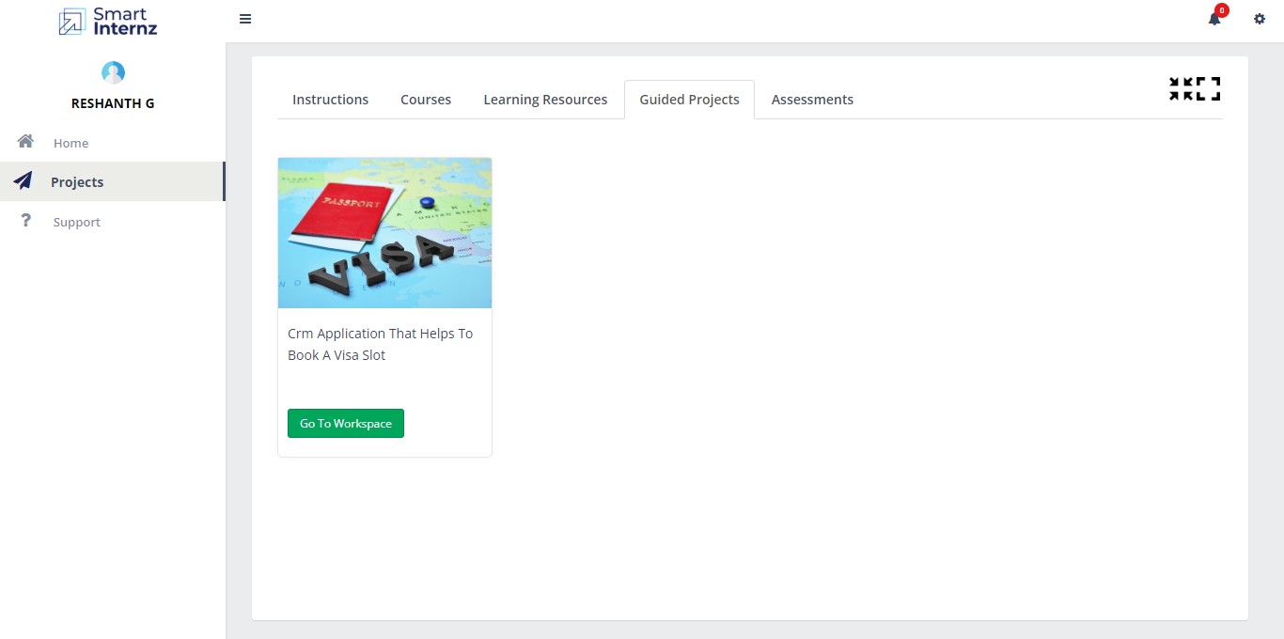

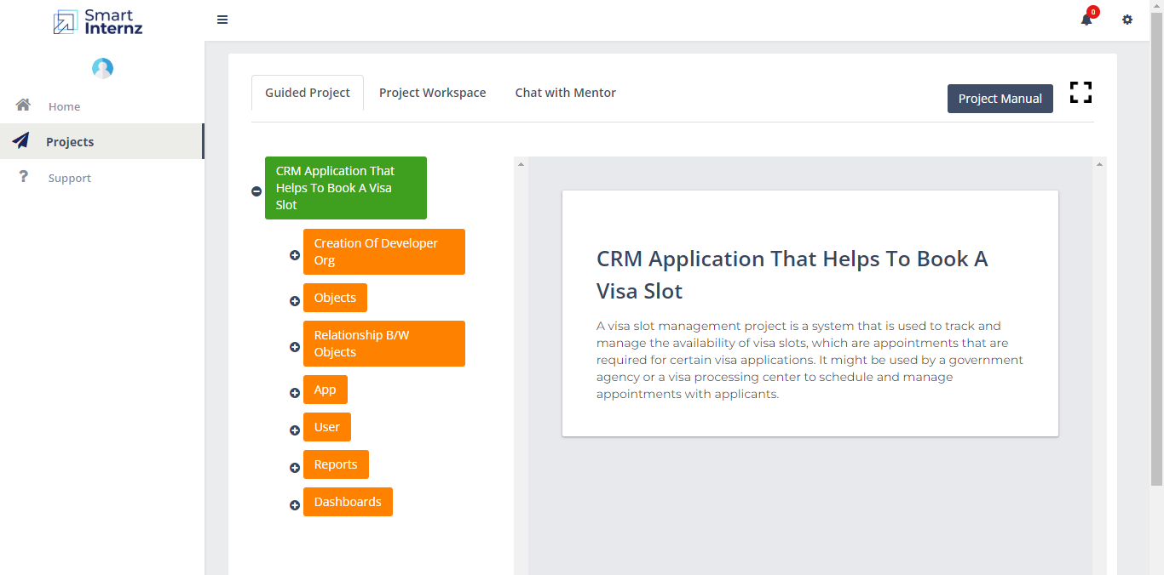

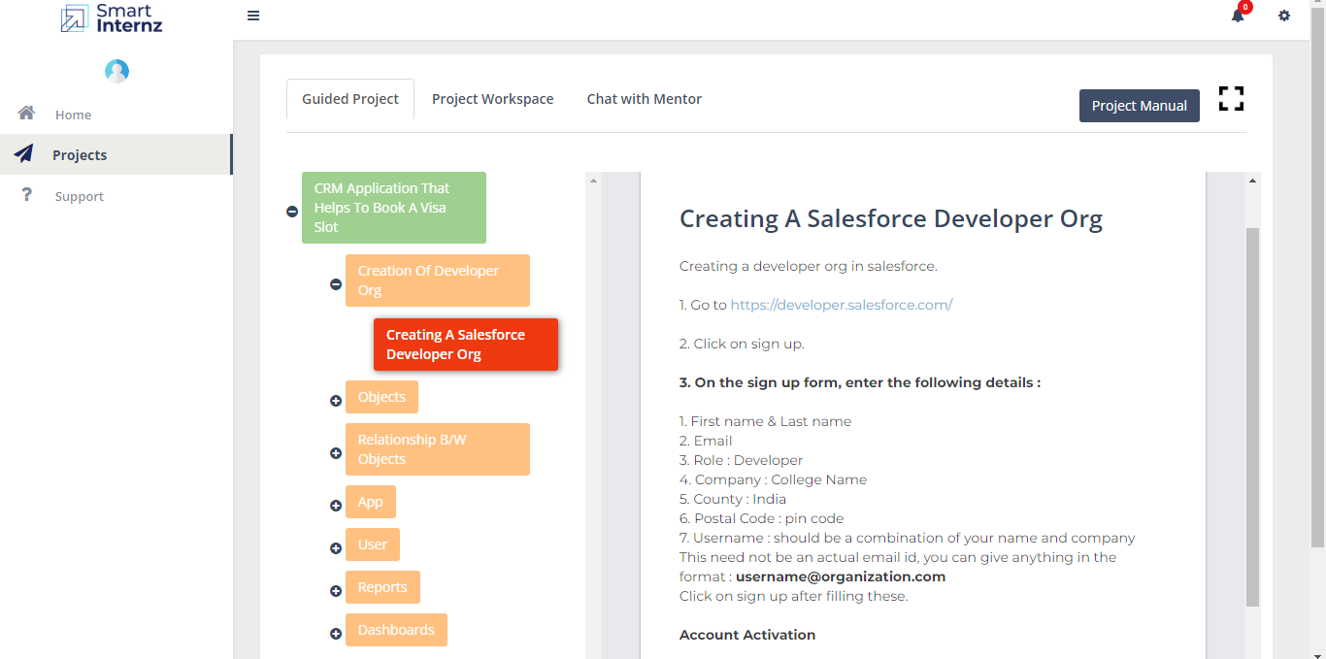**Creation of developer org:**

Creating Developer Account

Creating a developer org in salesforce.

1. Go to developers.salesforce.com/signup

2. Click on sign up.

3. On the sign up form, enter the following details :

1. First name & Last name

2. Email:

3. Role : Developer

4. Company : Chikkanna Government Arts College

5. County : India

6. Postal Code : 641-602

7. Username : should be a combination of your name and company

This need not be an actual email id, you can give anything in the

format :

username@organization.com

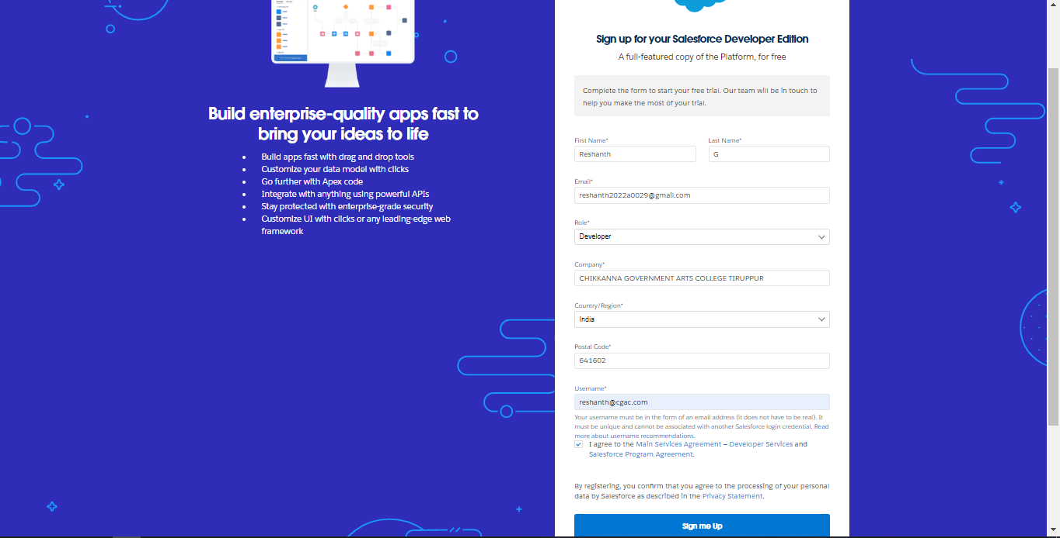

**Login To Salesforce Account:**

Go to htttps://login.salesforce.com

Enter the username and password

Users: reshanth@cgac.com

karthikeyan@cgac.com

gokulkrishnan@cgac.com

kathirvel@cgac.com

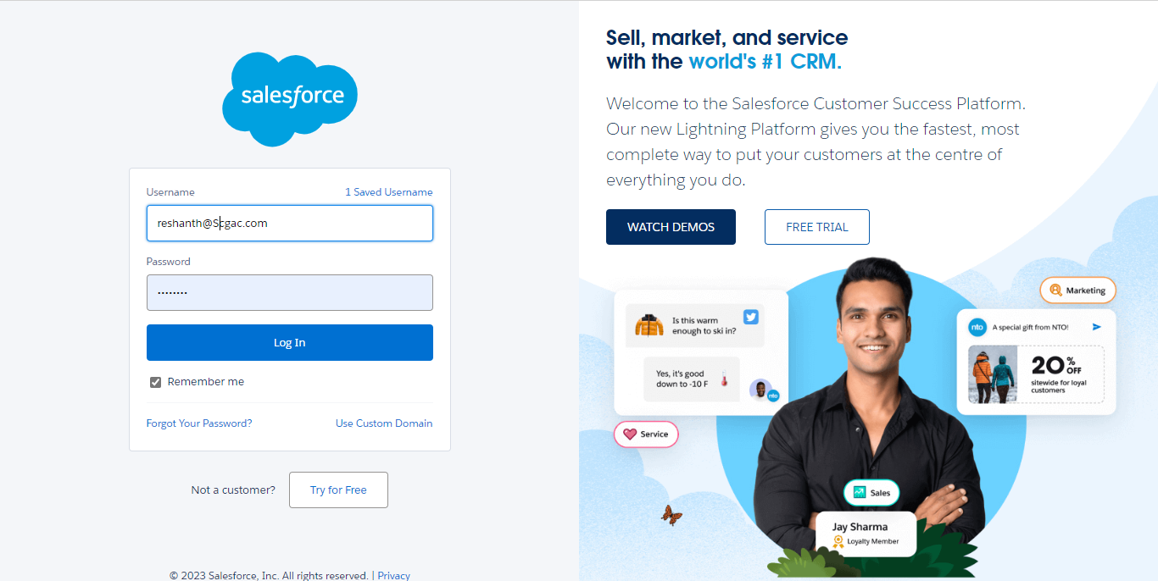

**Objects:**

1) Navigate to setup and select object manager.

2)At the top of the right side there you can find create custom object.

3) You will navigate to custom object definition edit where you have to give the object

name.

4) The label name has Passport and Plural label has Passports.

5) In enter record name label and format enter name record name has passport number

6) And the data type has text.

7) In deployment status select deployed option.

8) Ensure that you have to select at least one option in the object creation option; it is

available only once when a custom object is created.

9) Then click on next you will navigate to the new custom object tab where you have to

select tab style and click on next.

10) After tab selection you will be navigated to add to profiles select default on click on next.

11) Thereafter you have to select a custom app select include tab so that object will be

available in all objects and select save option.

12) Continuing this process for objects visa slot,payement,reshedule/cancel.

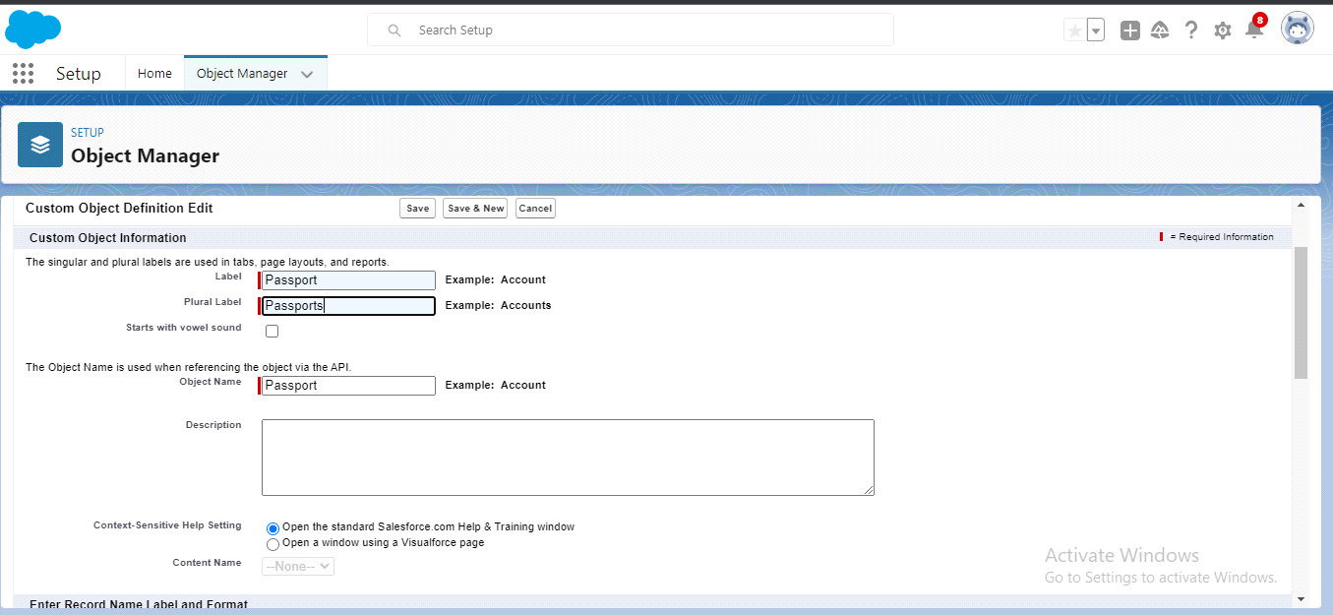

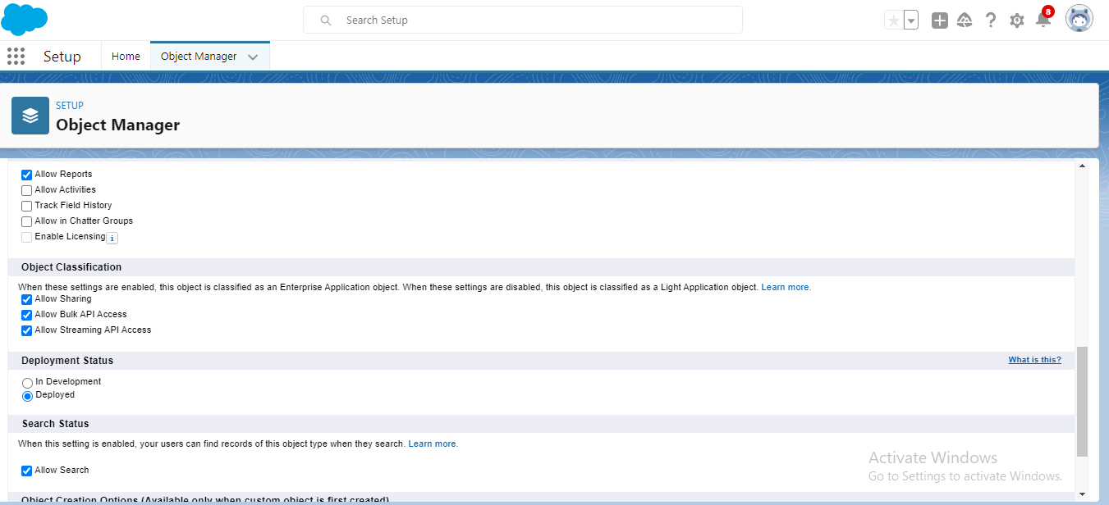

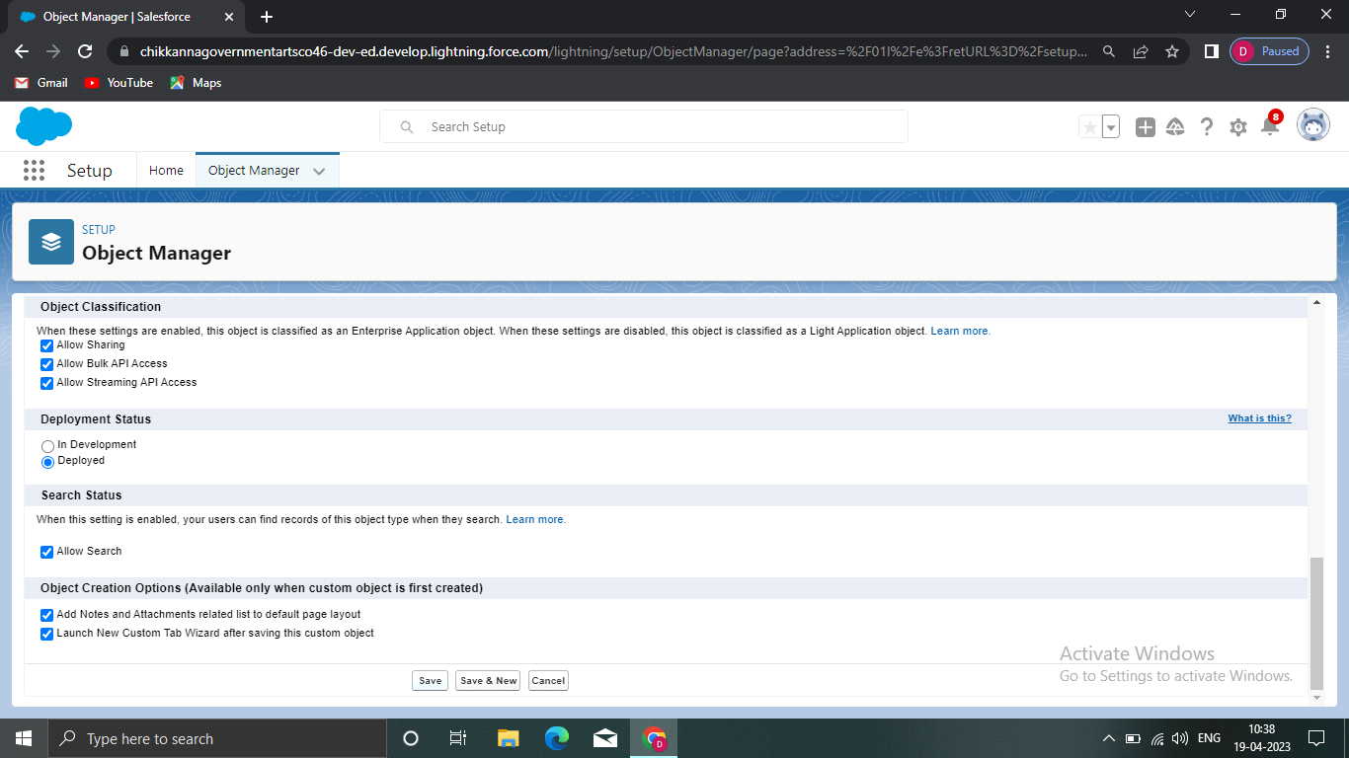

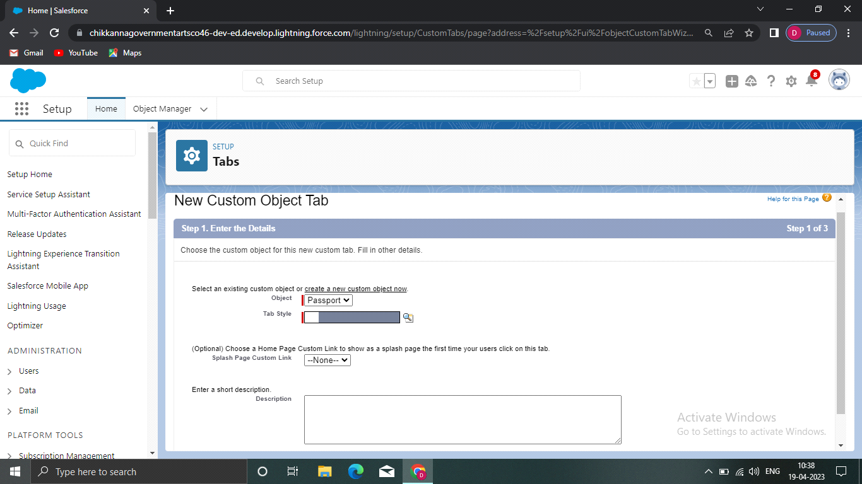

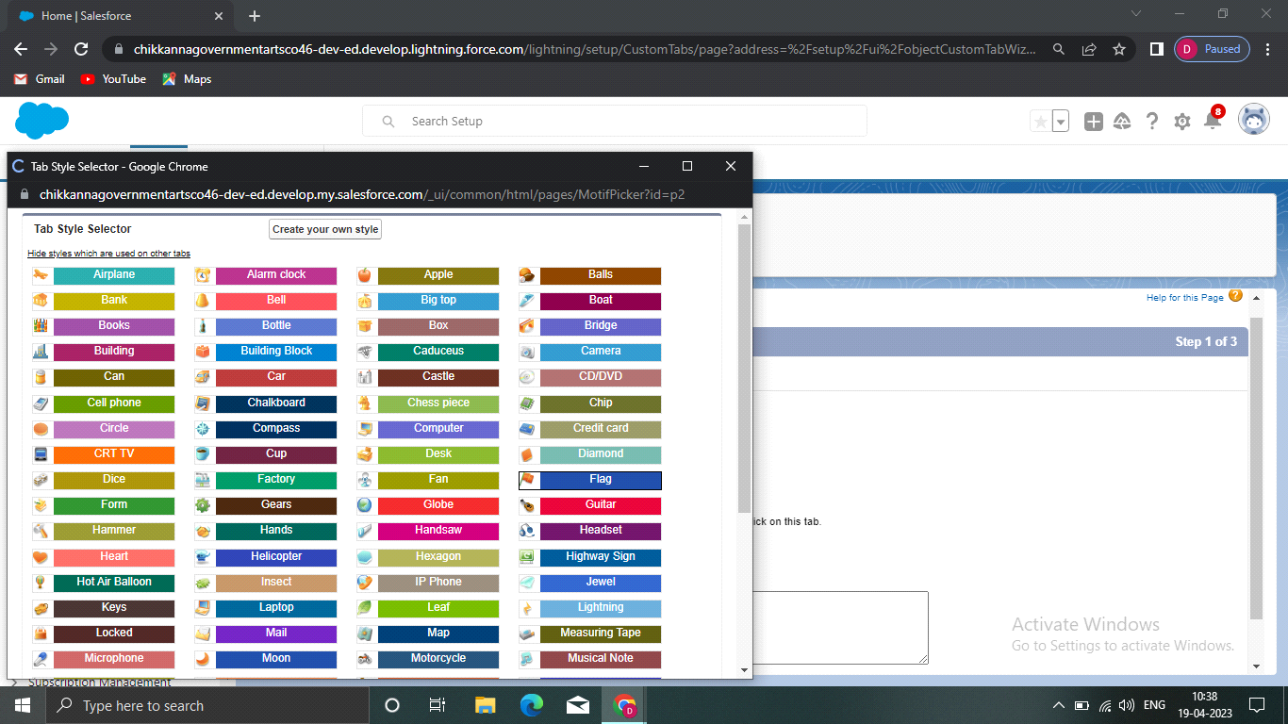

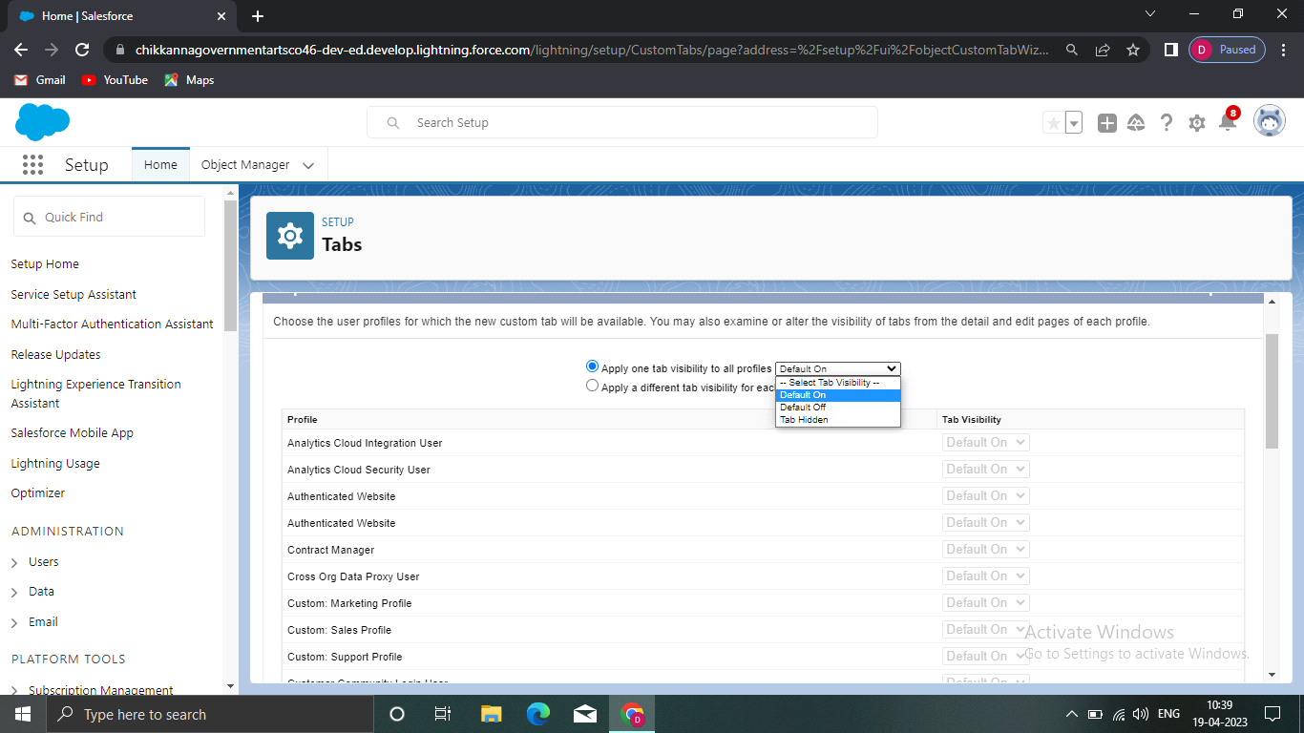

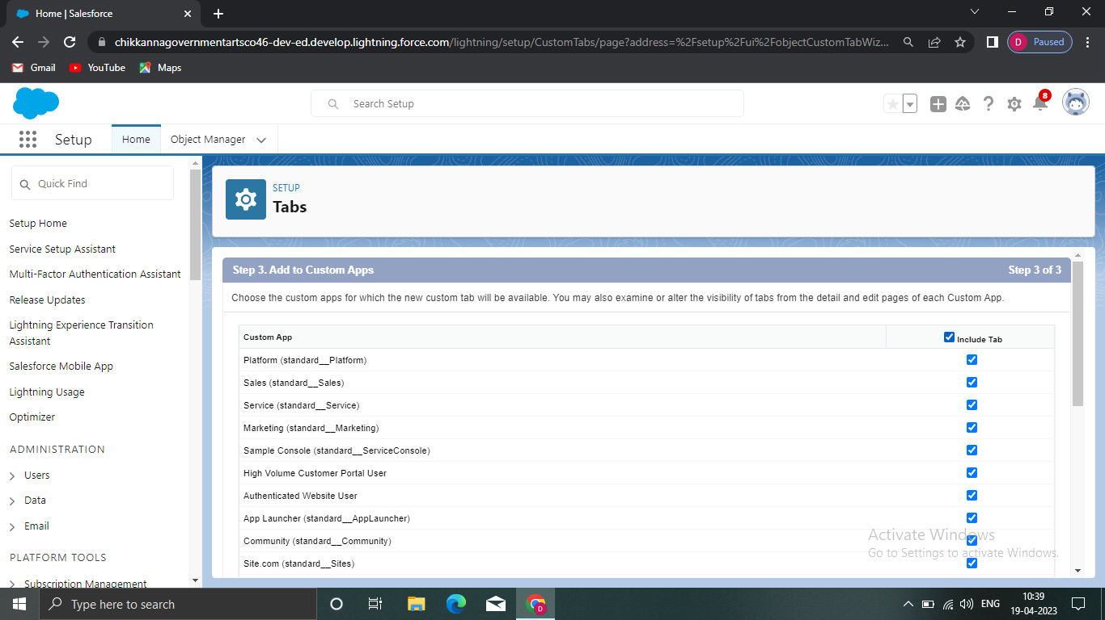

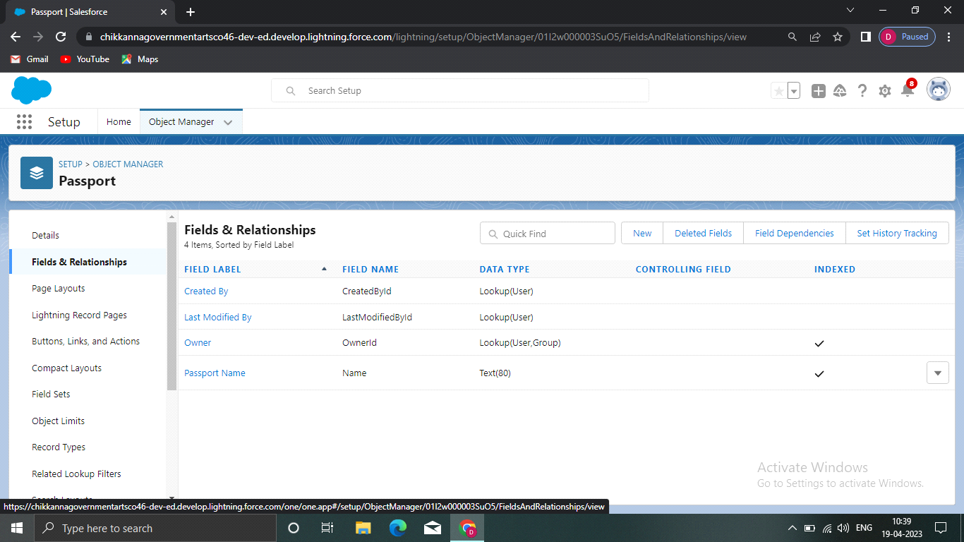

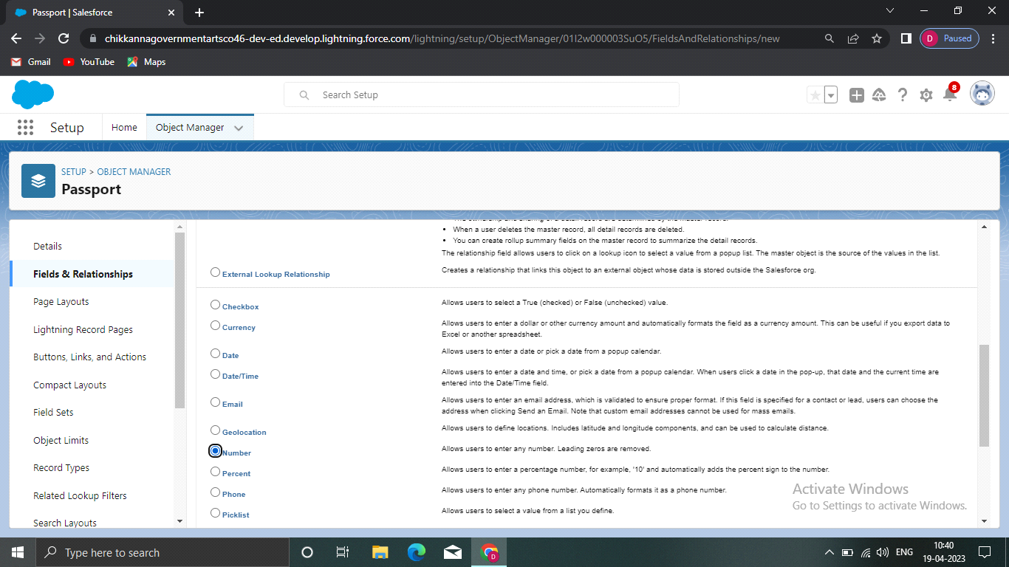

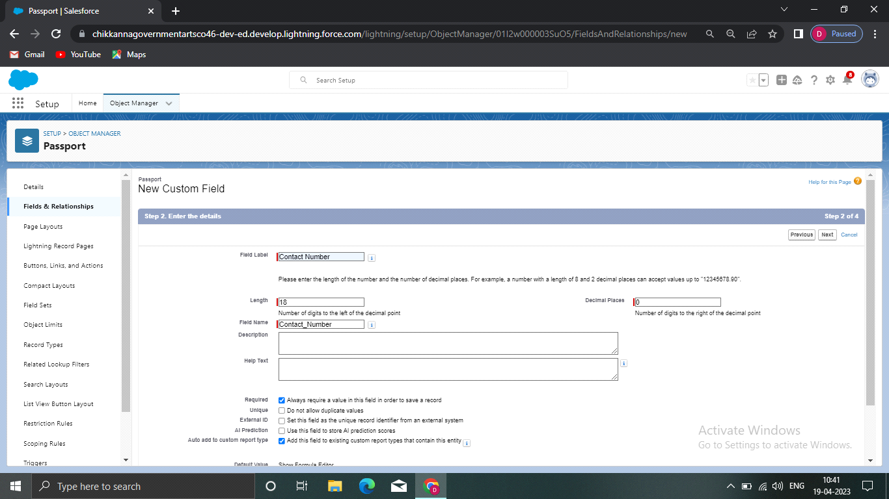

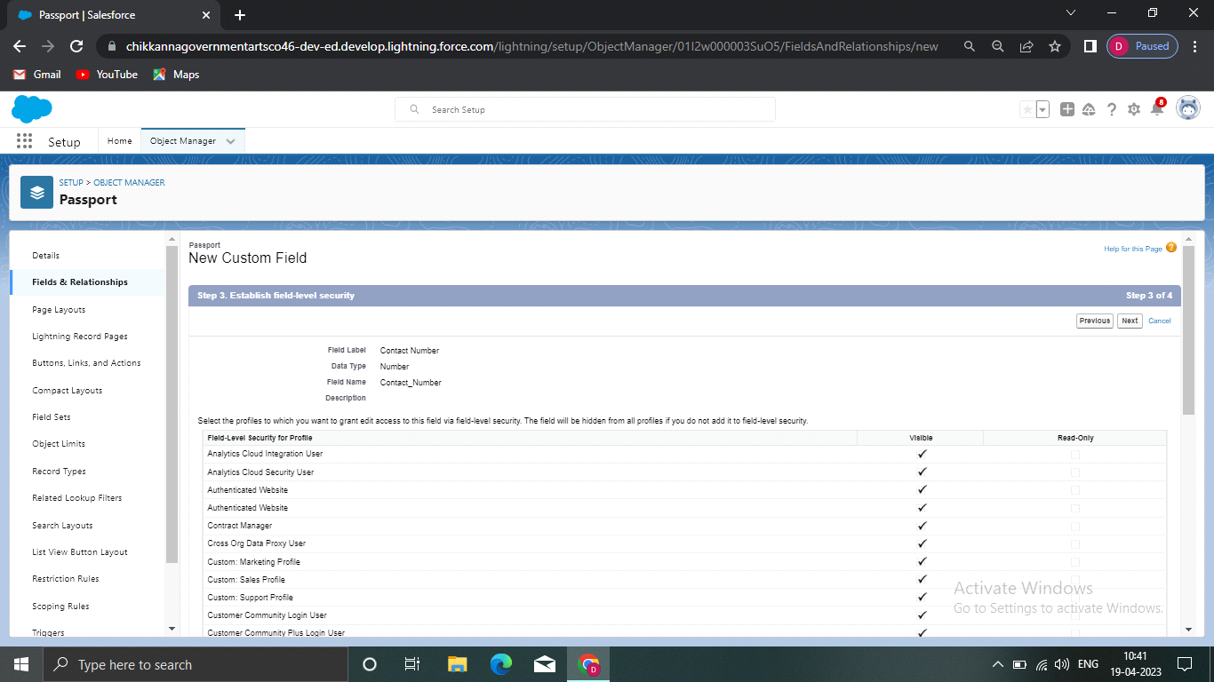

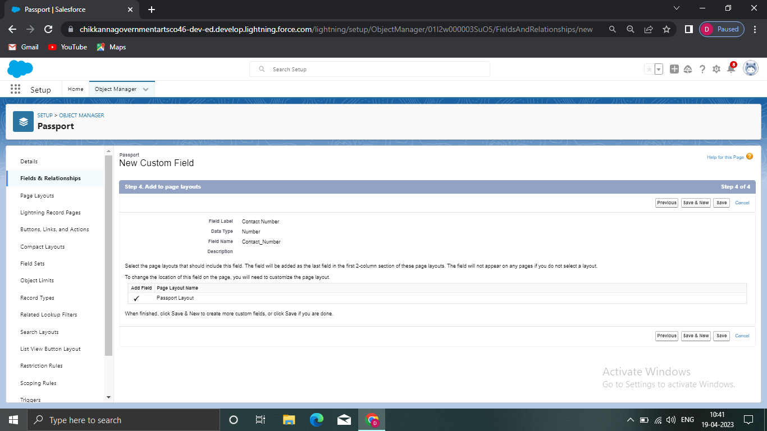

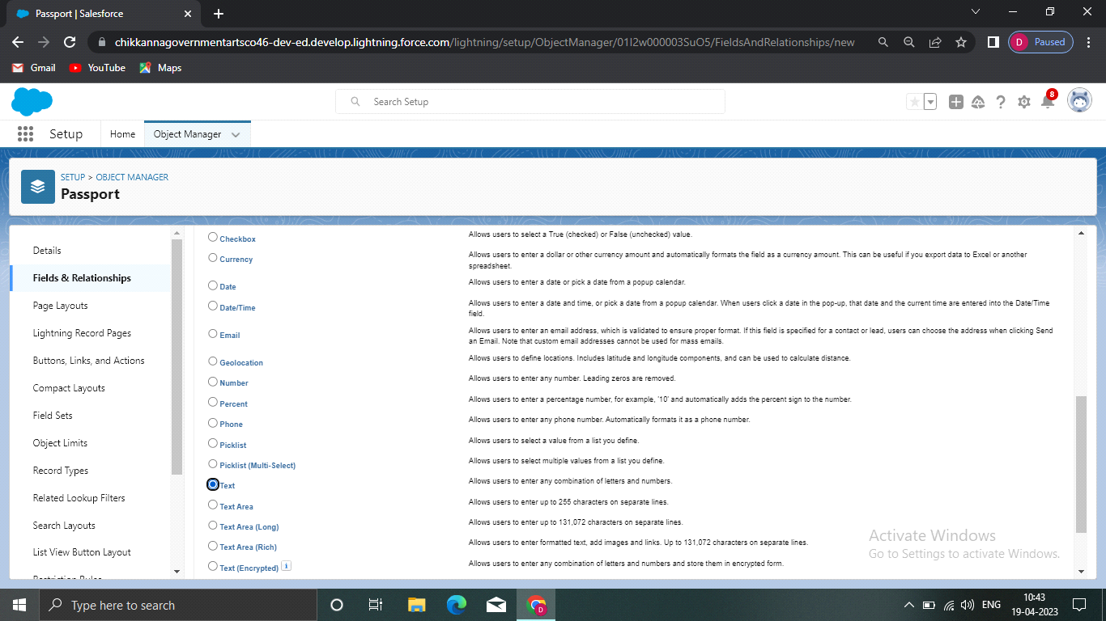

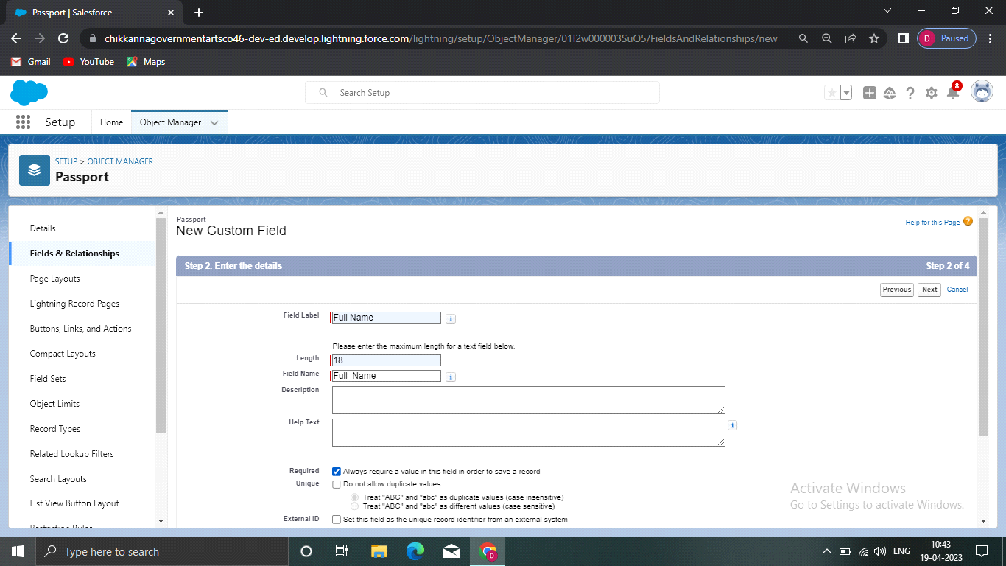

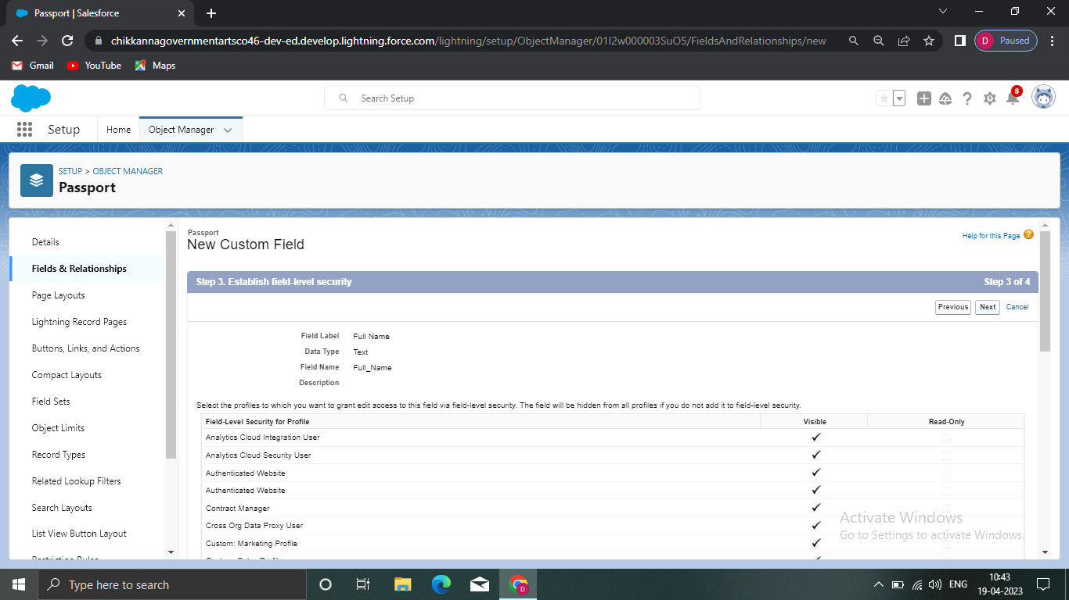

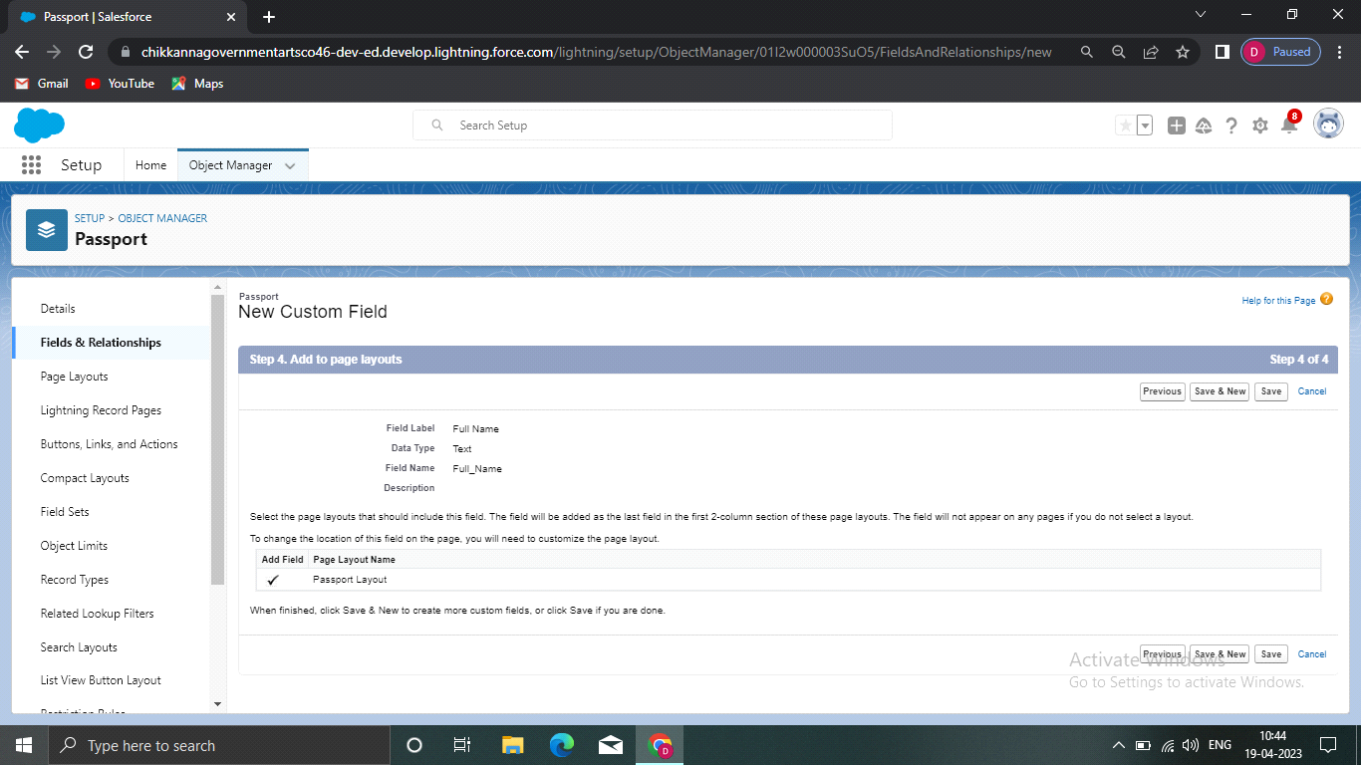



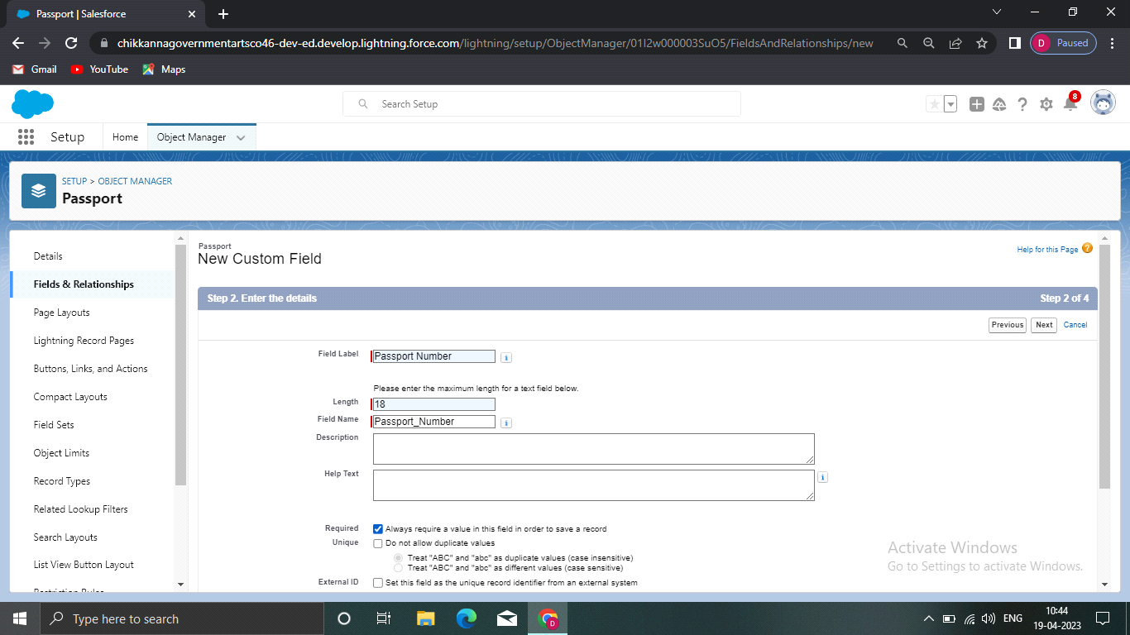

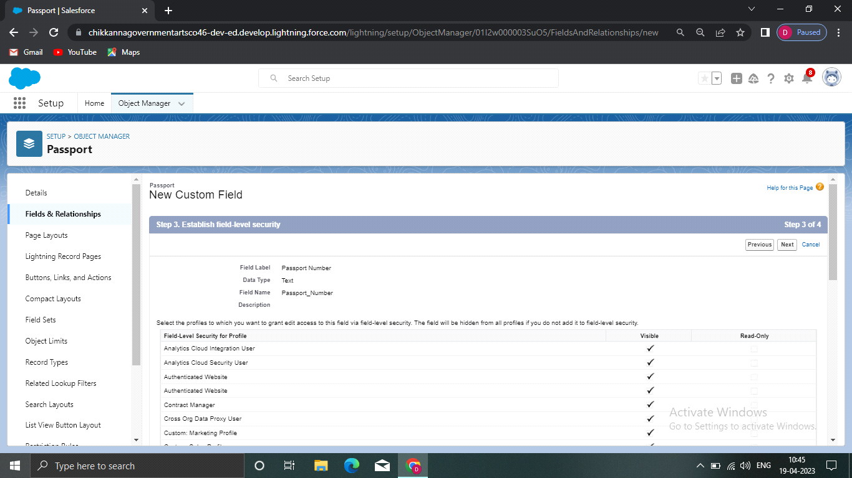

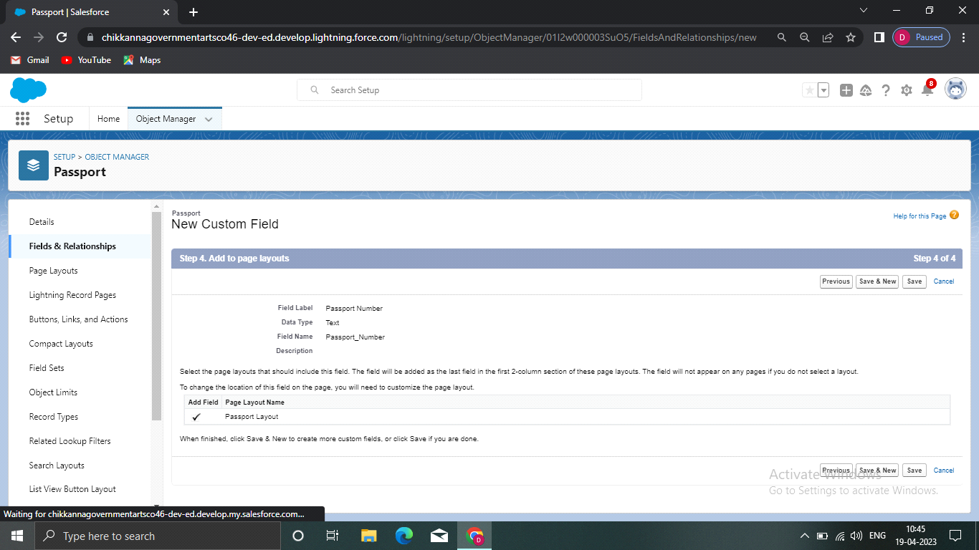



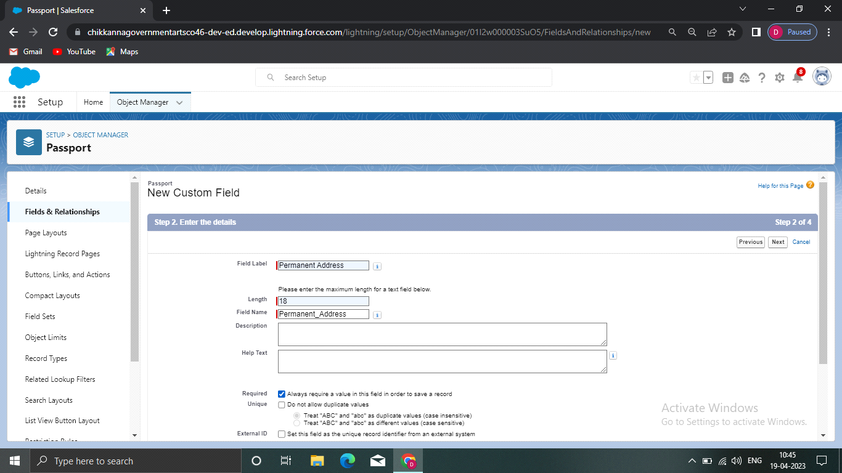

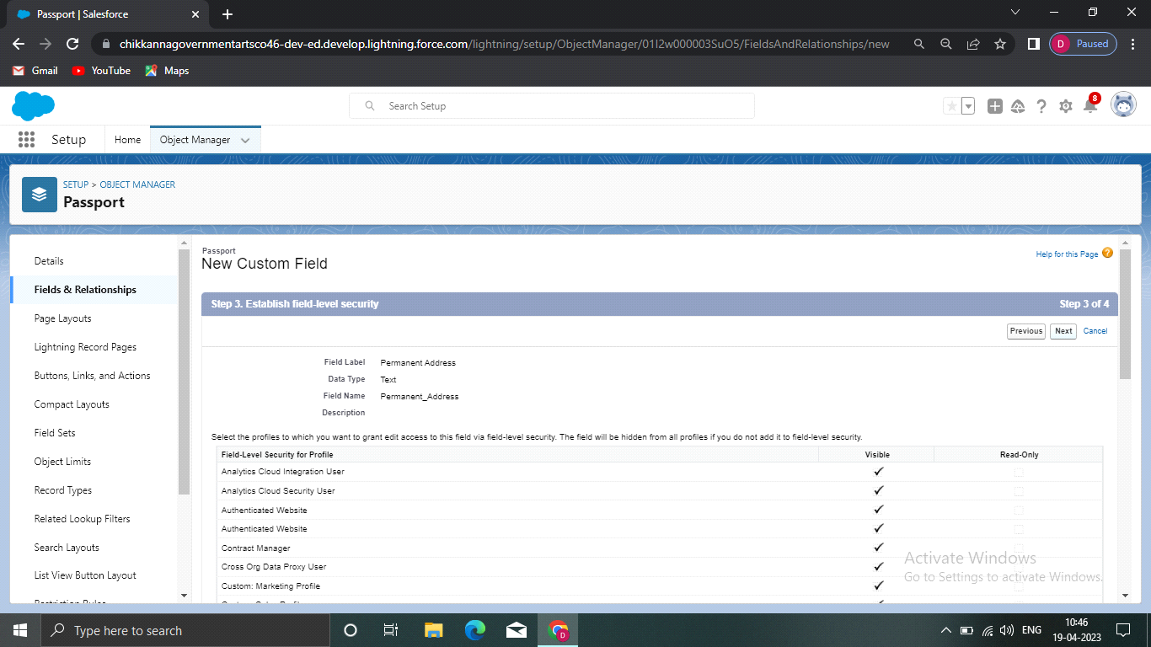

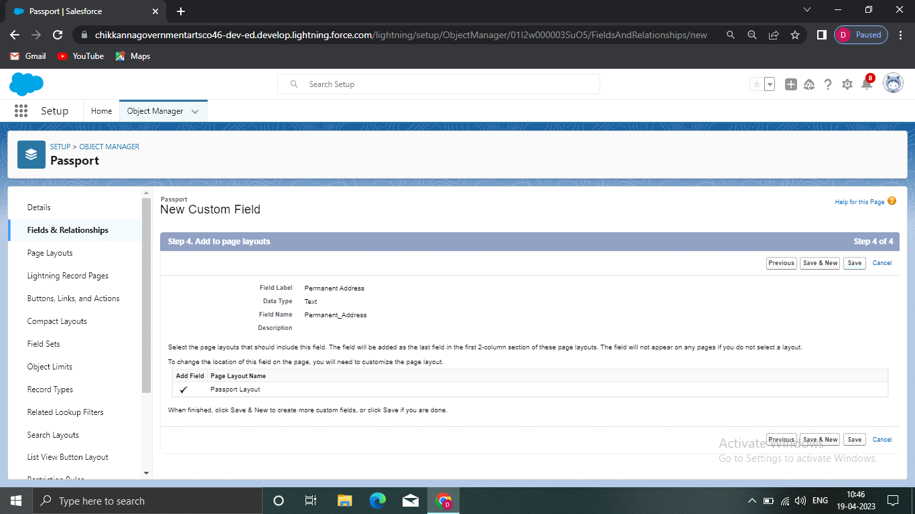

**Visa Slot**

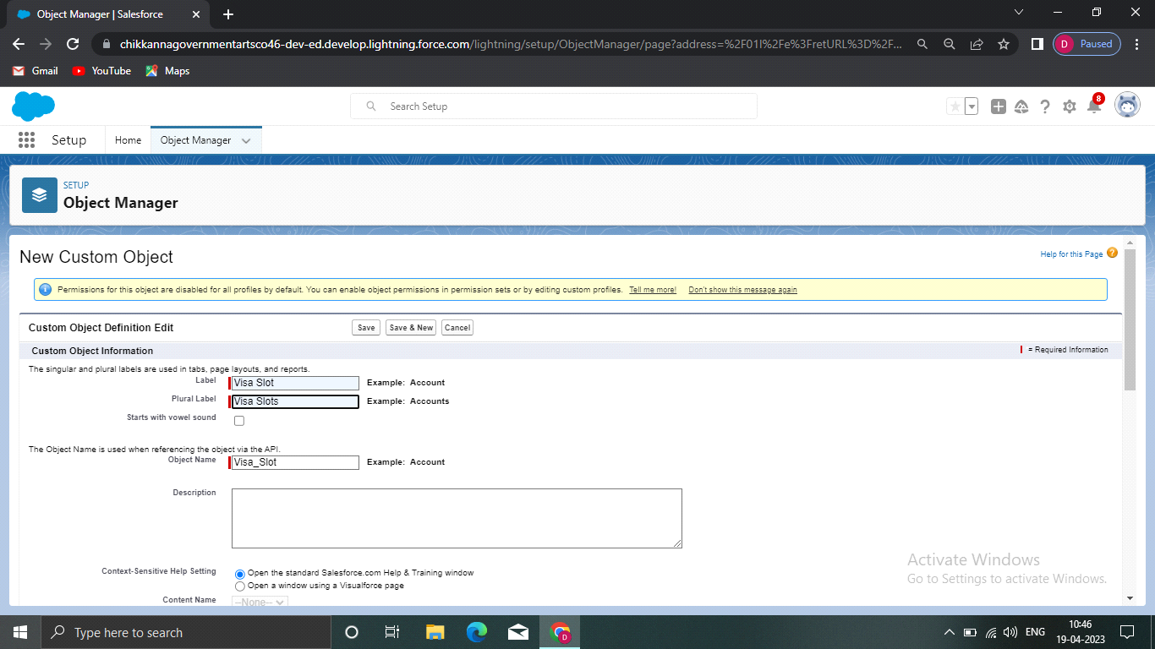

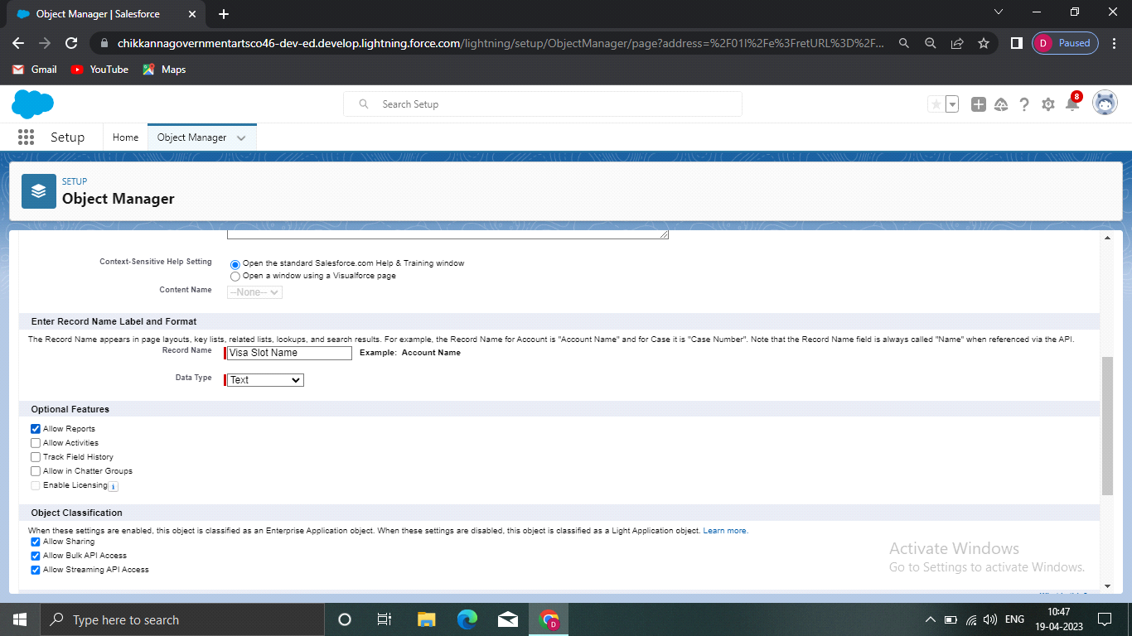

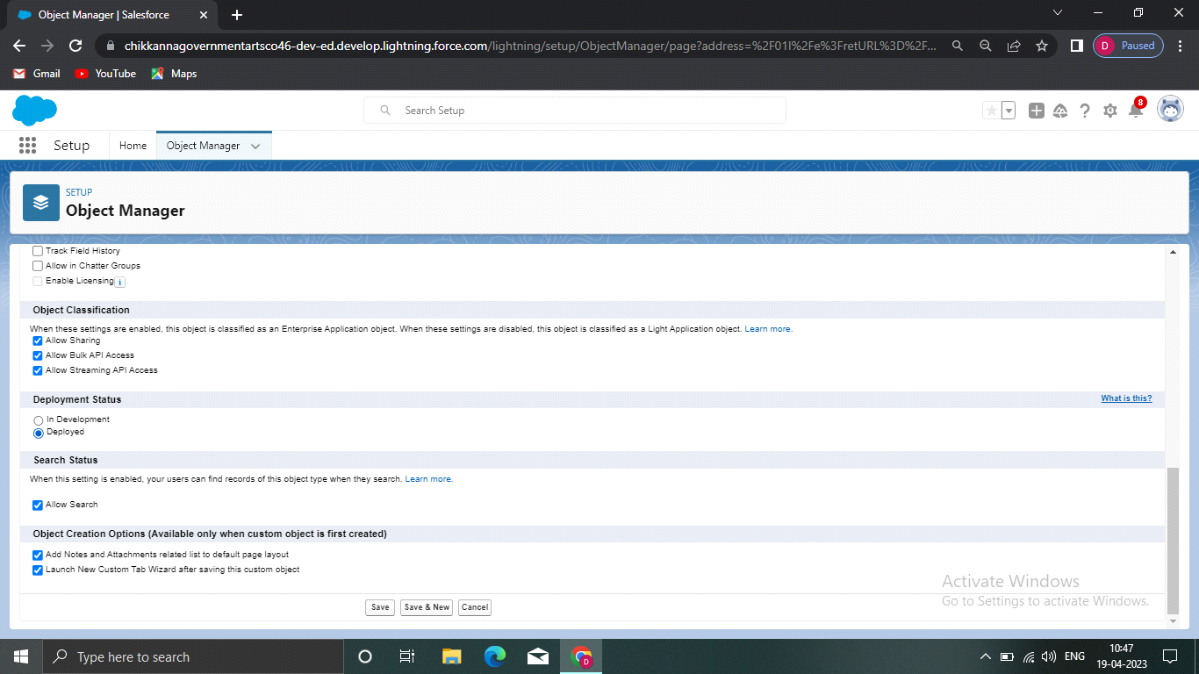

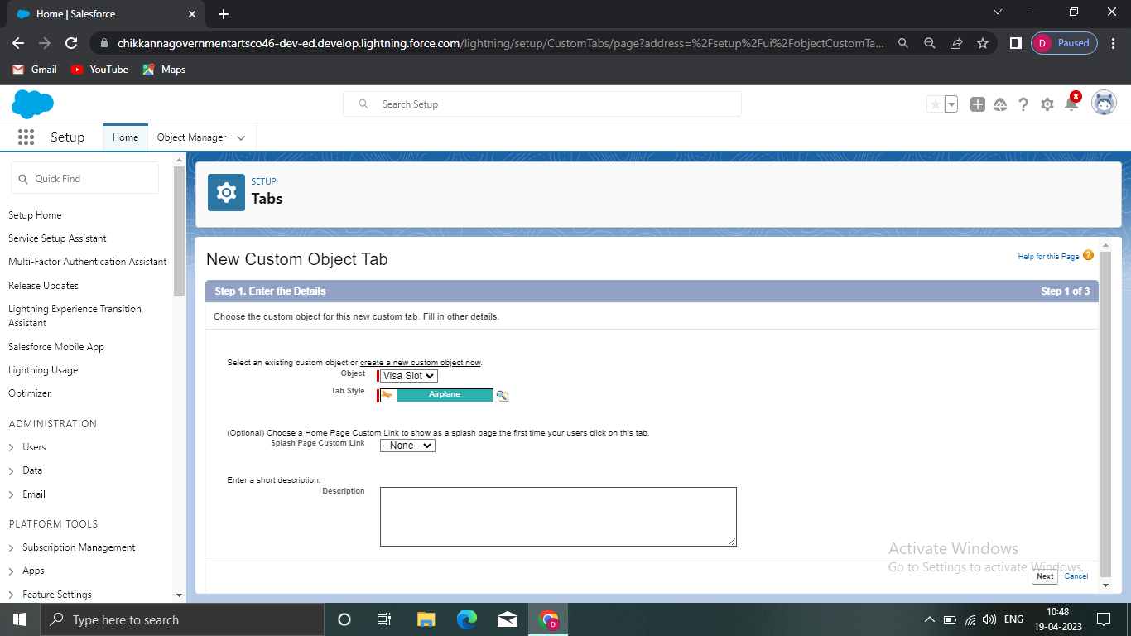





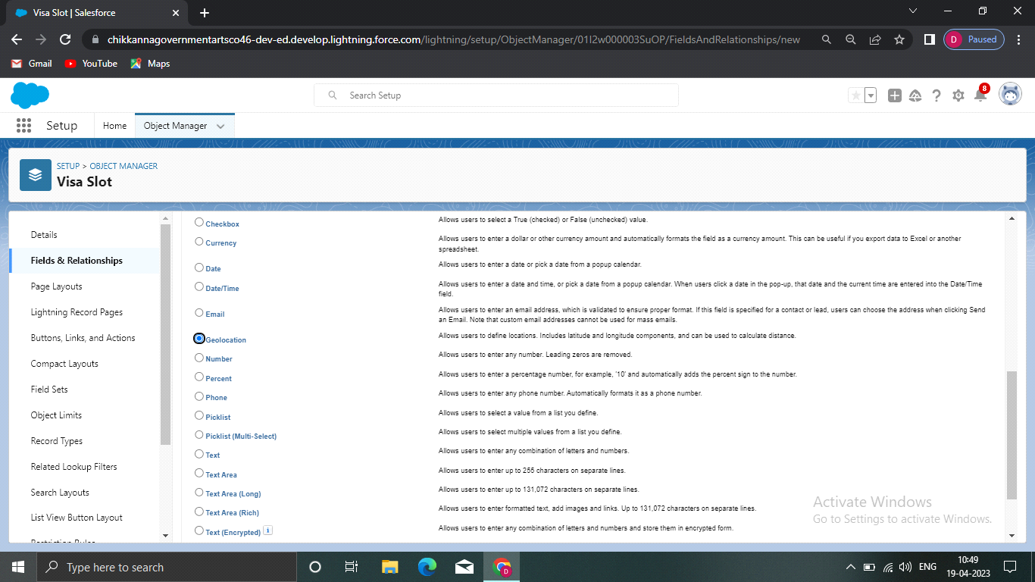

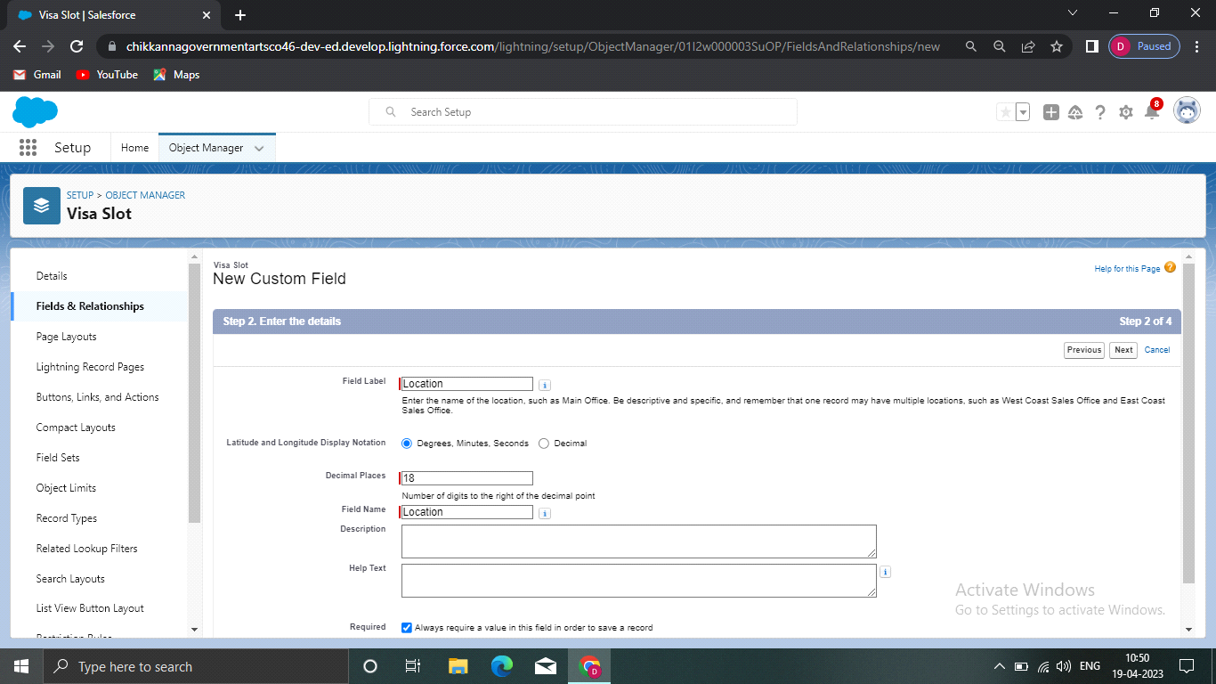

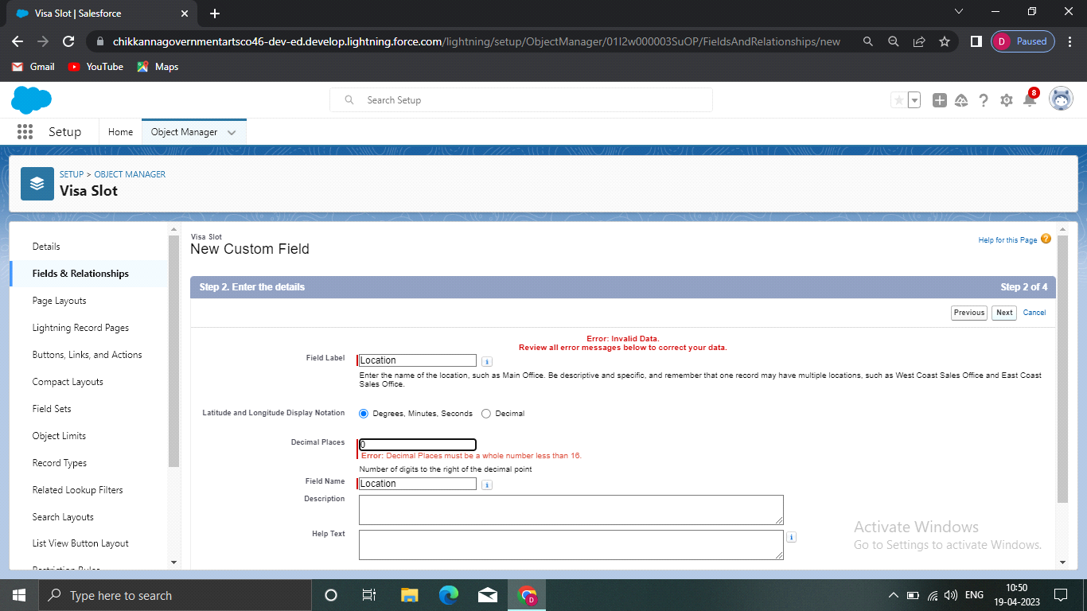

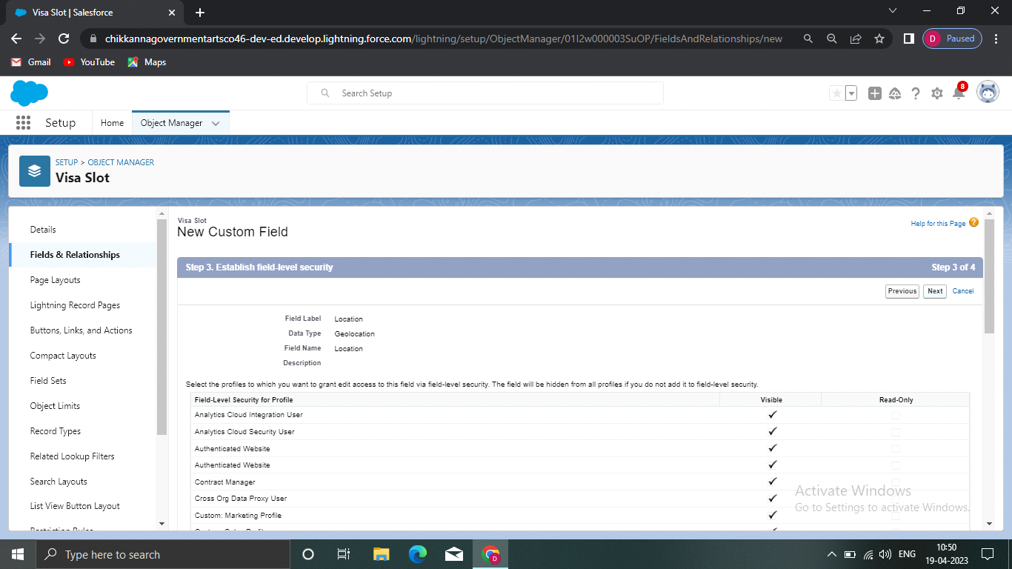

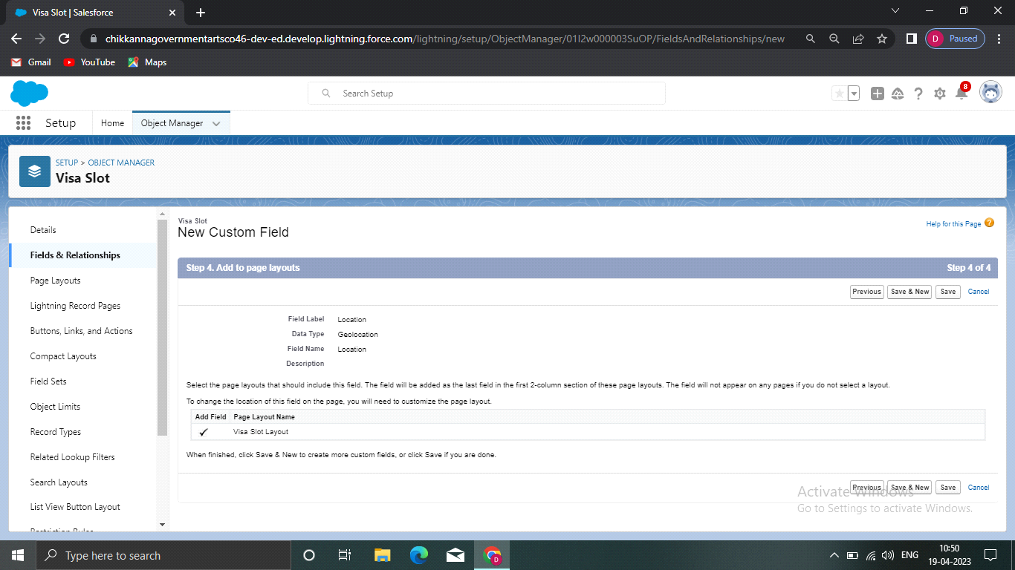

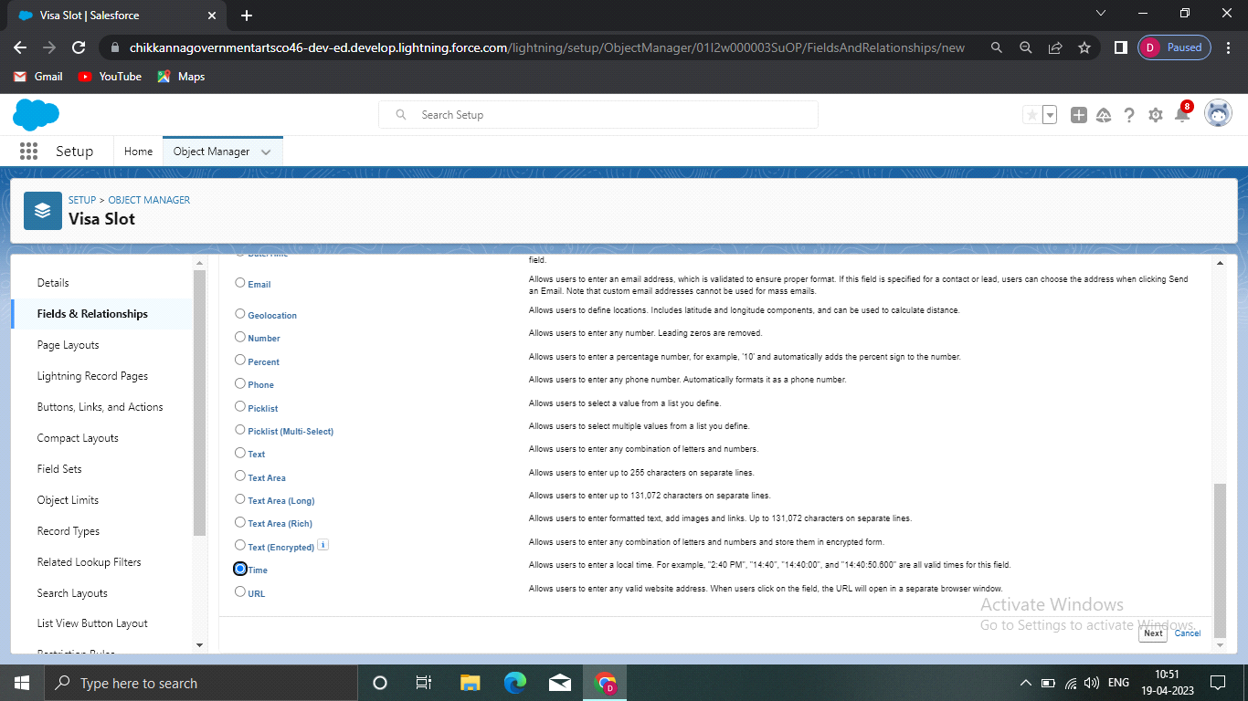

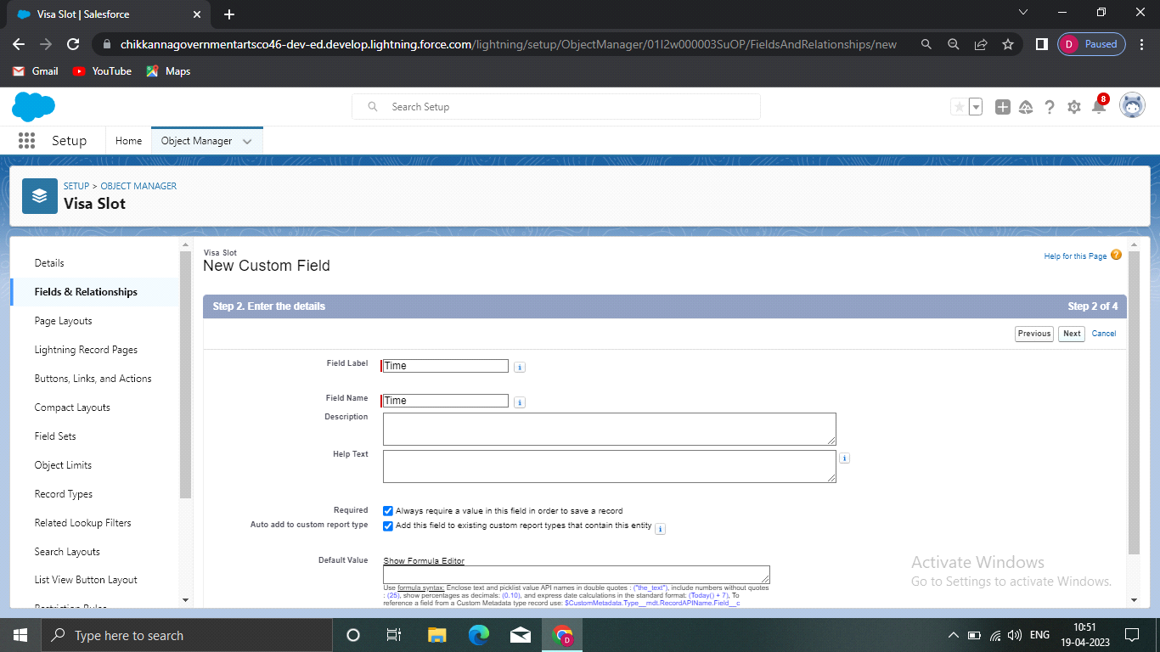

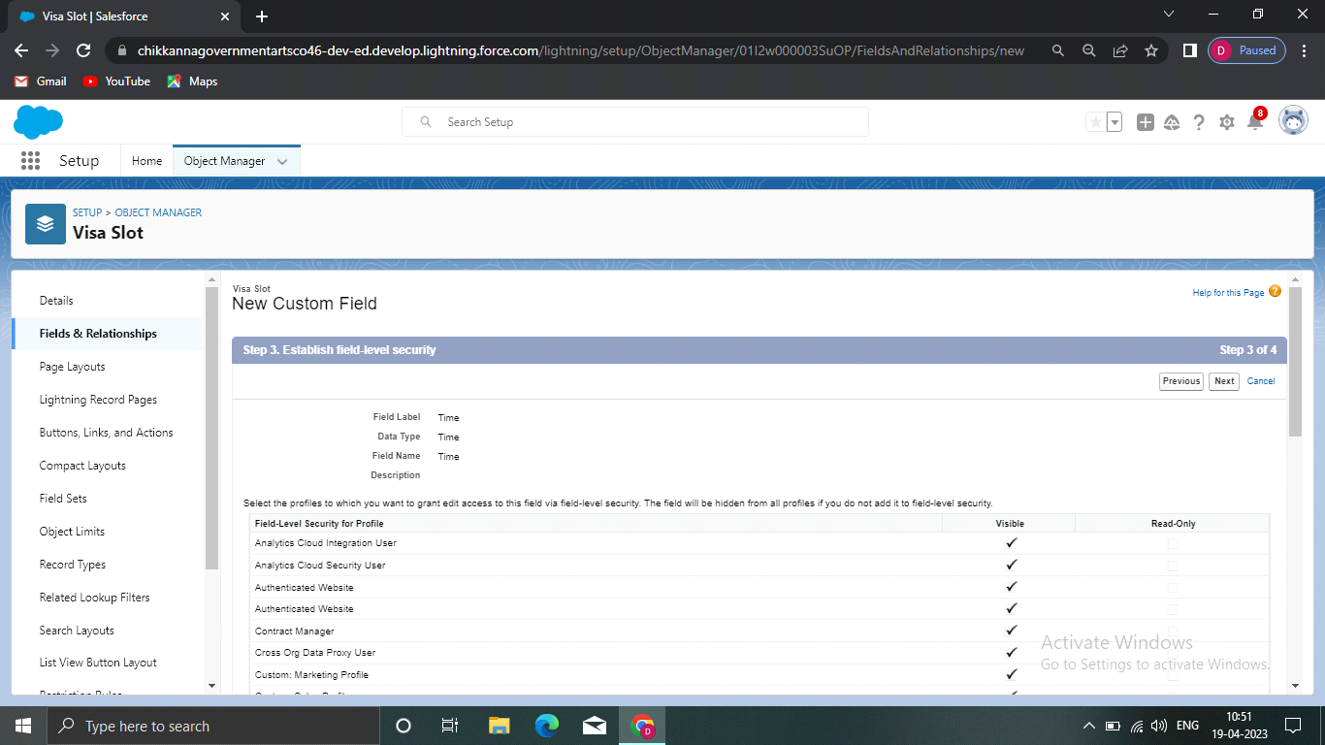

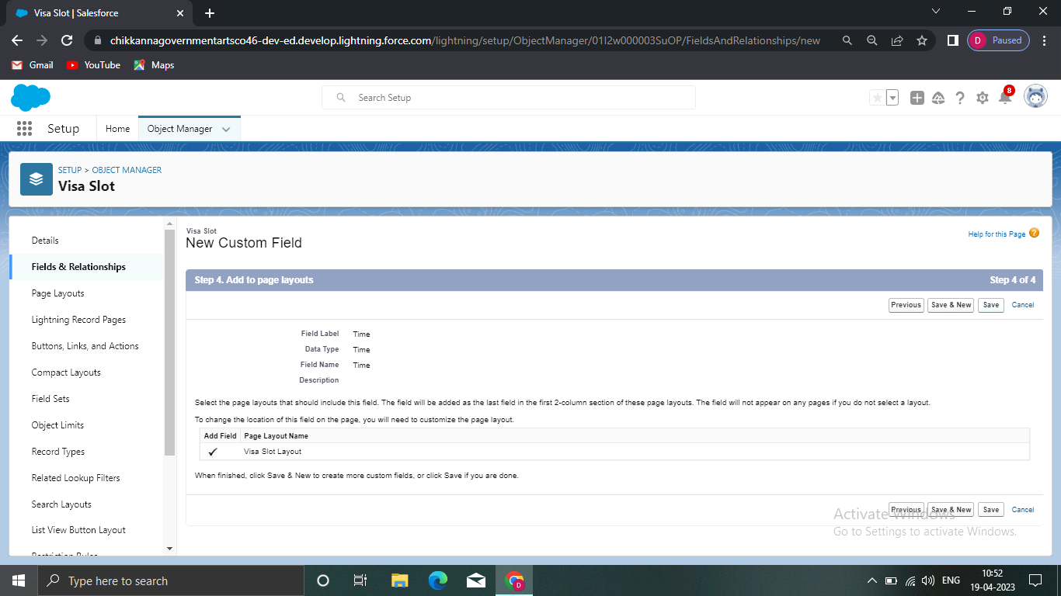

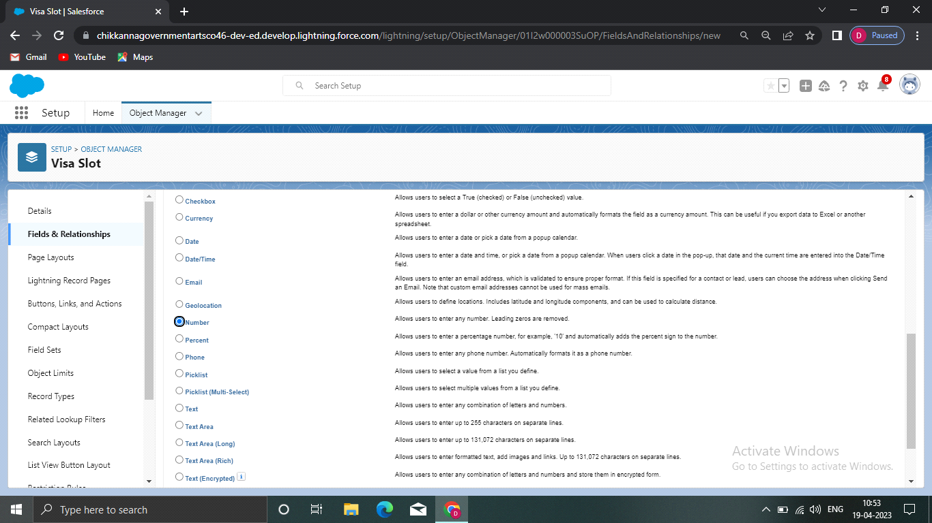

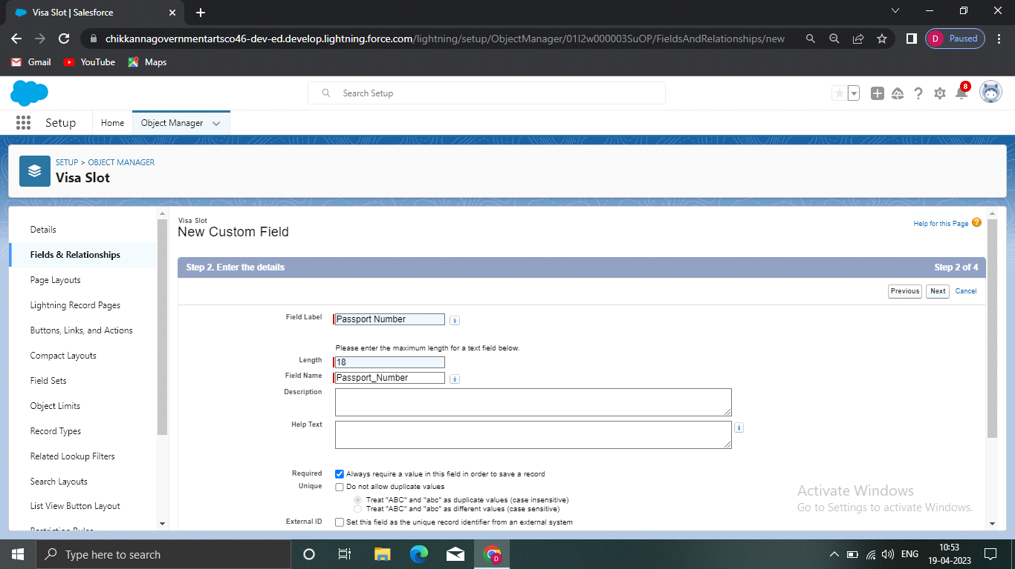



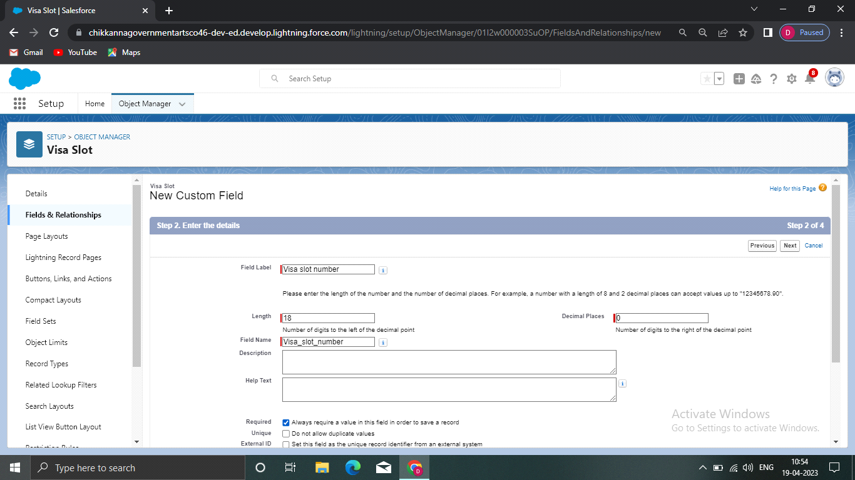

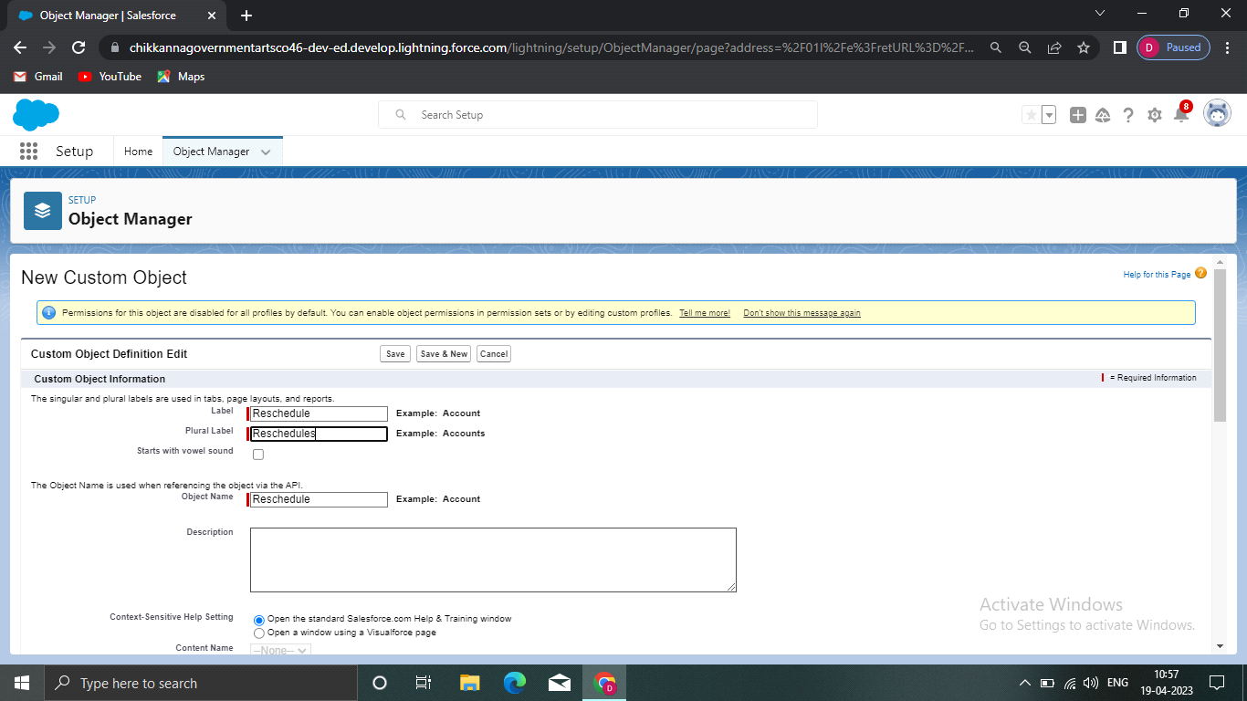

**Creation of Relationship**

To create a Master Detail relationship between Passport and Visa.

1) Go to the Set Up option from the Home Page and click on it.

2) Go to the object manager and select ‘visa’ object from the list

3) And select fields and relationships and click on new.

4) Select the data type has Master detail relationship

5) And select related to the object has passport, and click on next

6) You will navigate to the label name page where you give the label name for the field, give it has

passport number and click next.

7) Select visible for all profiles in field level security and select page layout in next page and save it.

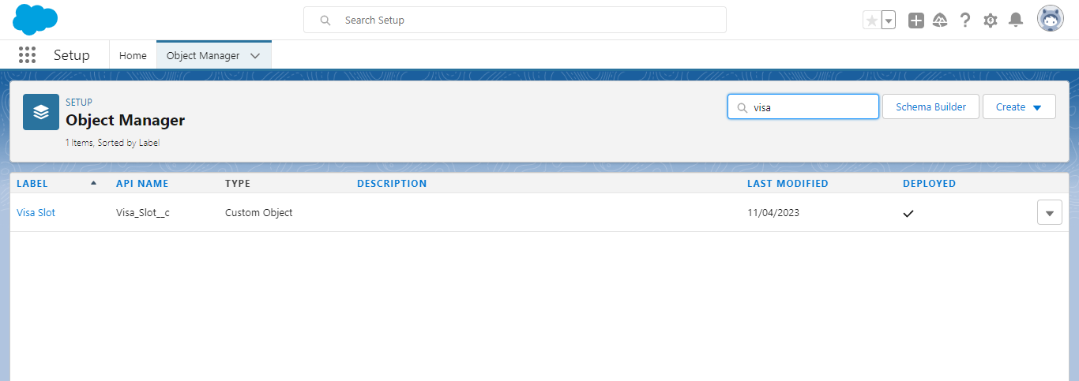

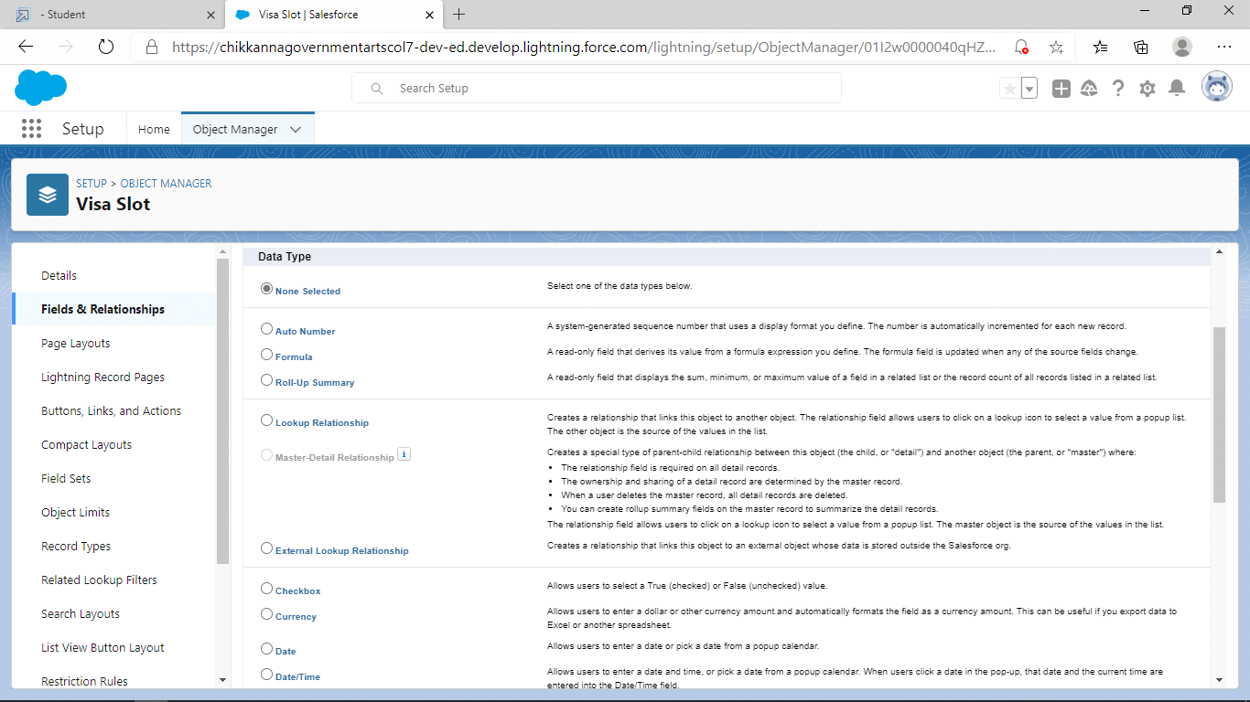

**Creation of App**

1) Navigate to setup and search for app manager

2) And select an option for a new lightning app.

3) Give the app name has book my visa.

4) Upload the picture and click next.

5) Choose the app option as navigation style- standard navigation, support from factors-desktop &

mobile and select next.

6) And move the objects from available items to selected items.

7) Passport, visa slots, payments,reschedule/cancel to selected items.

8) And system admin profile to available items to selected items.

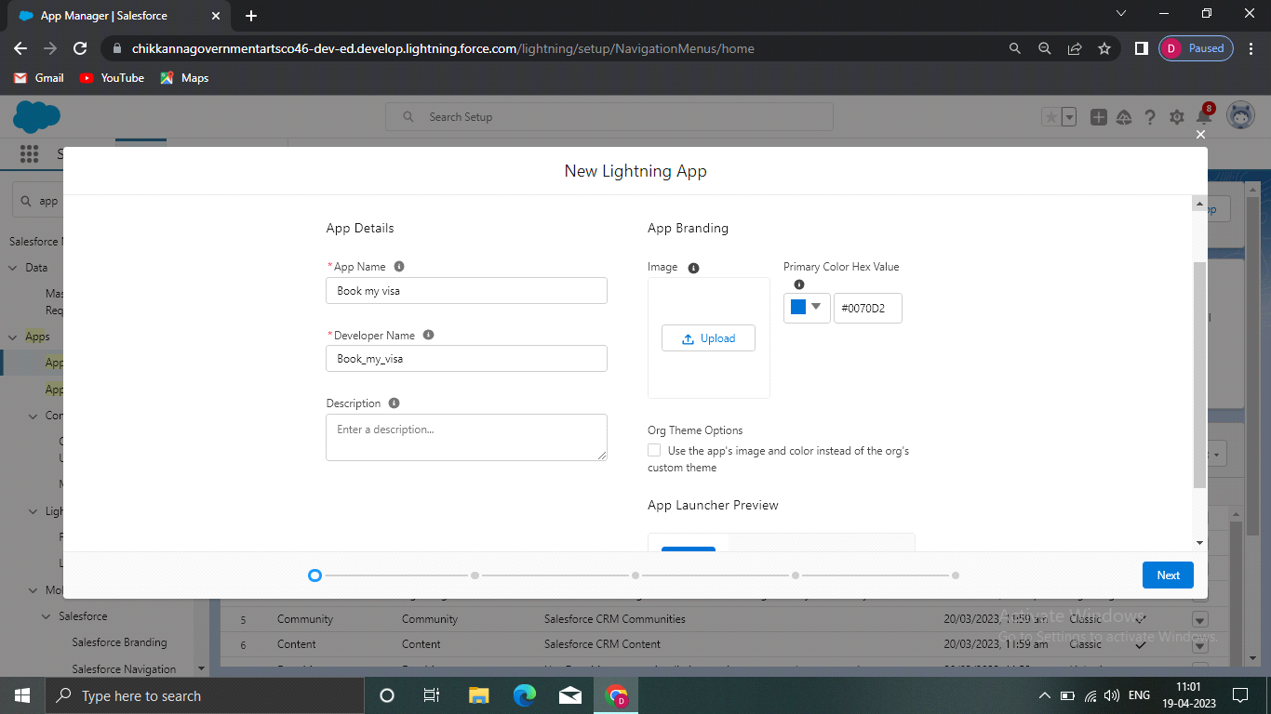

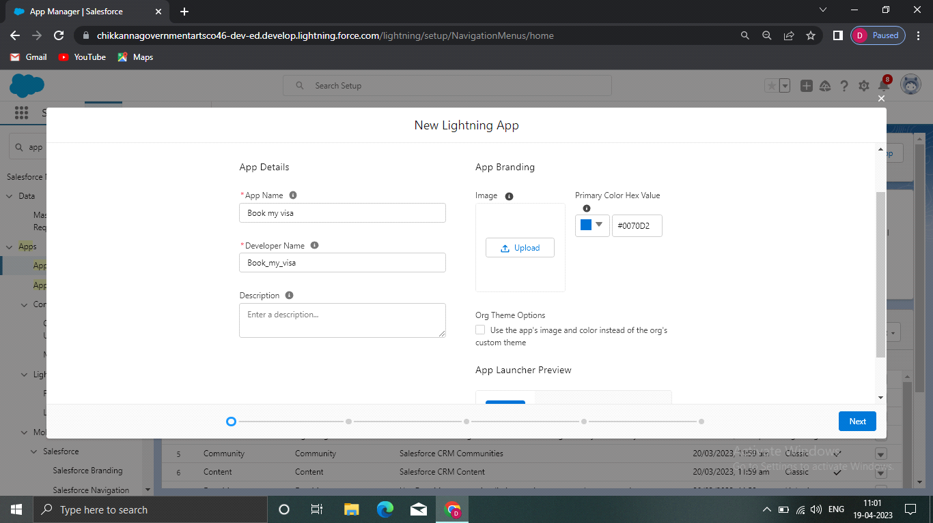

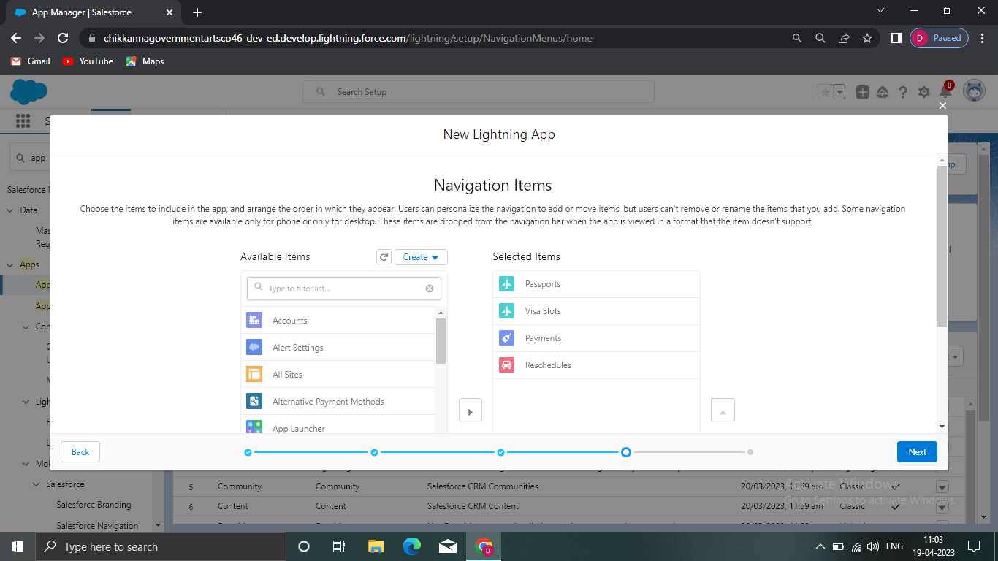

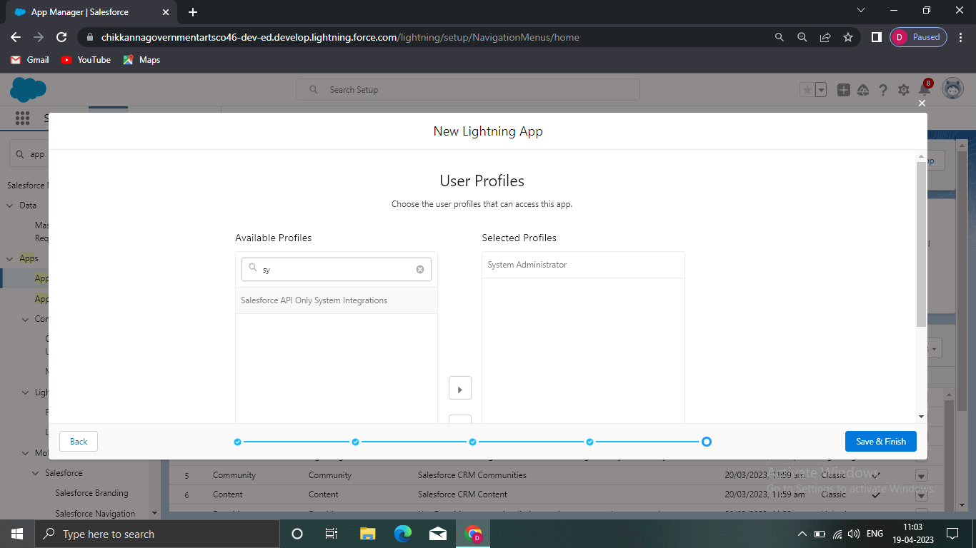

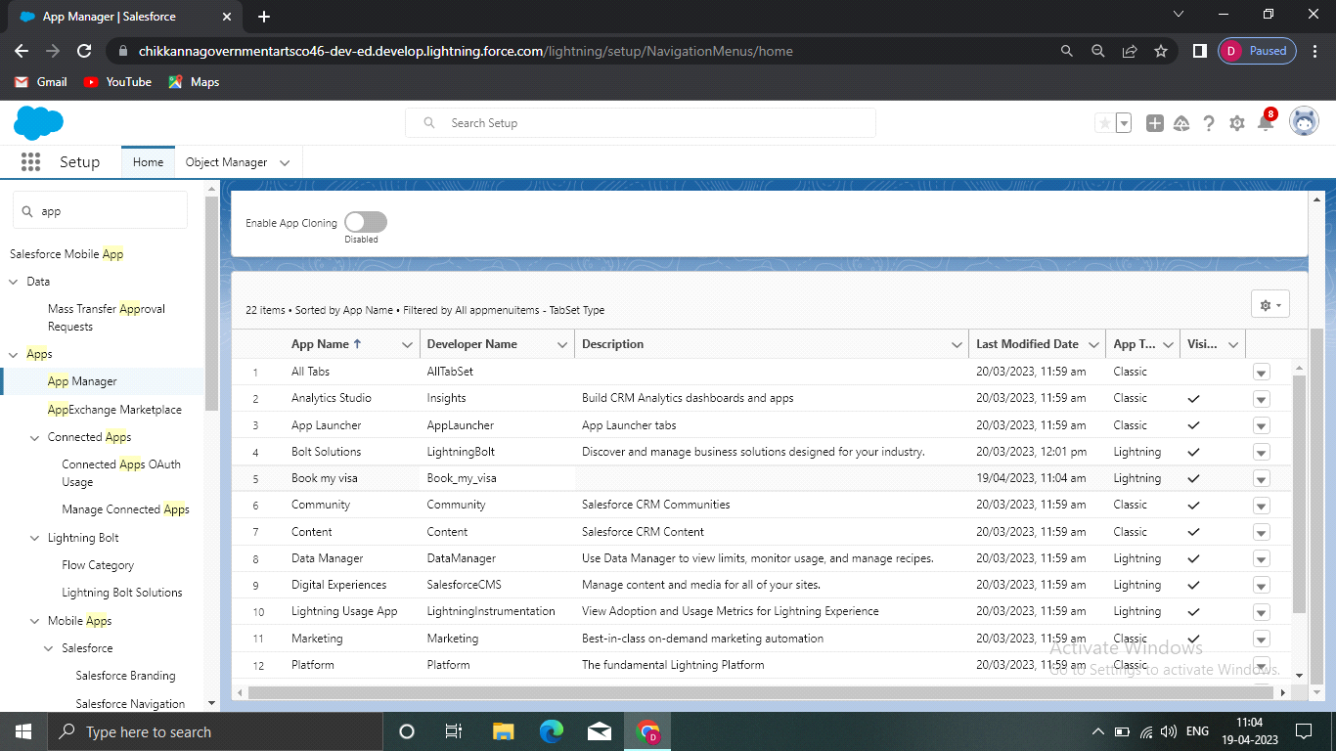**Creation of User**

1) Navigate to setup in quick find search bar

2) Type user in and select it and click on new user.

3) Give the first name and last name.

4) Enter your email in the email field.

5) Enter username; it must be unique.

6) Select the user license of salesforce.

7) In the profile field select standard user

8) At the bottom of the page check the box to generate a new password and notify the user

immediately.

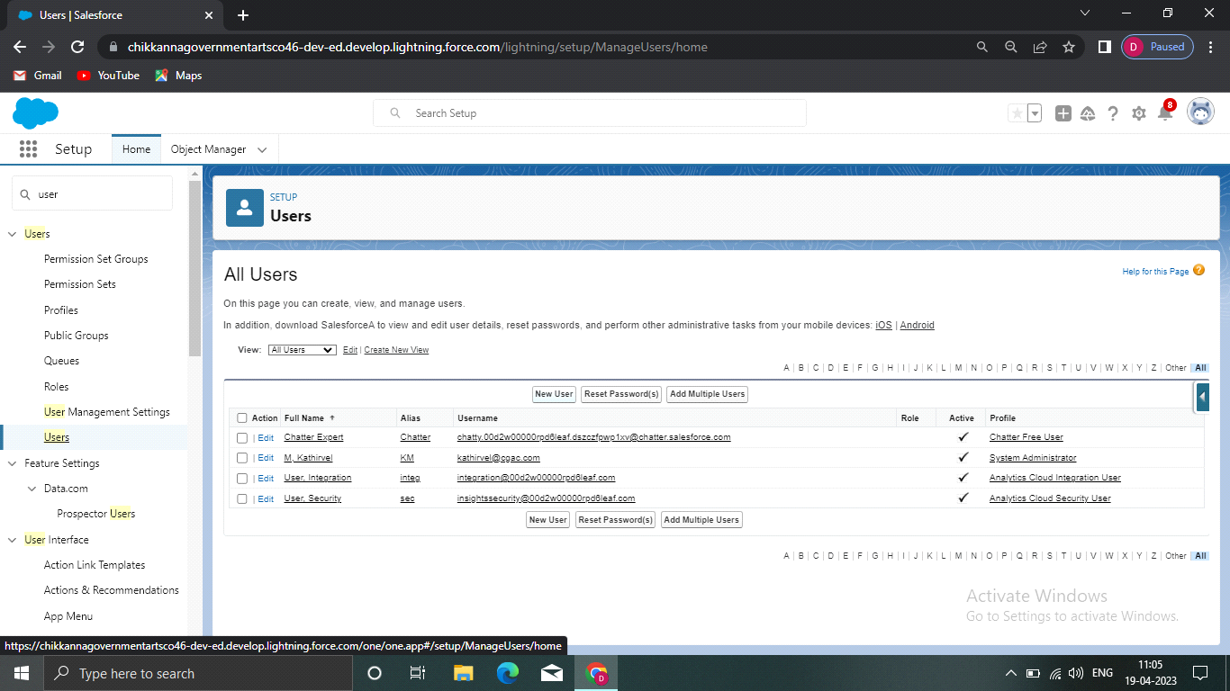

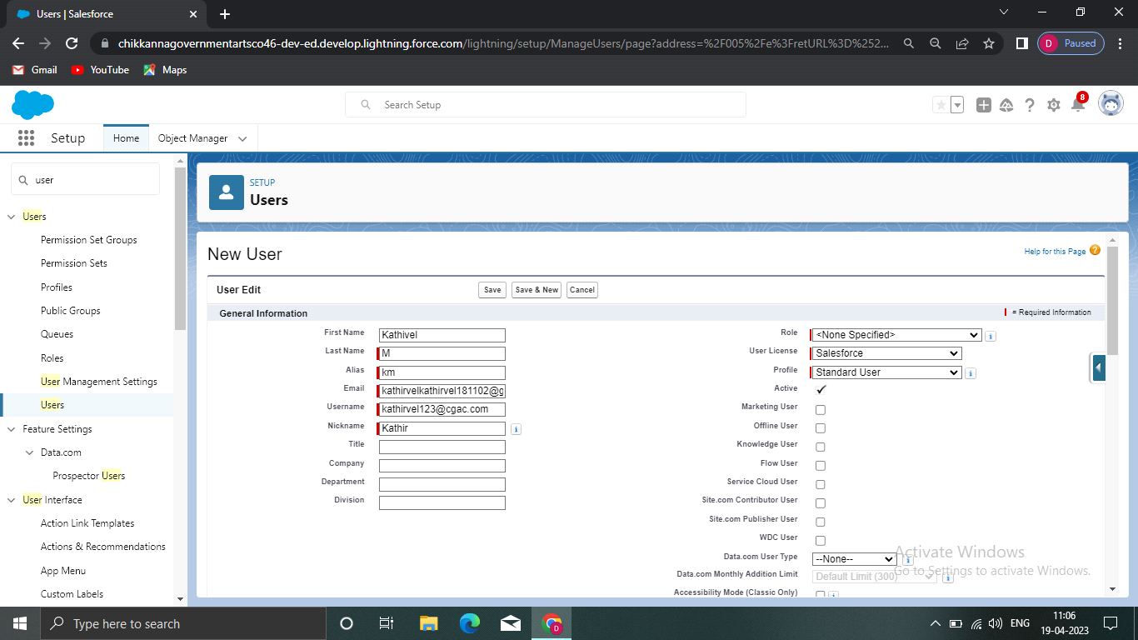

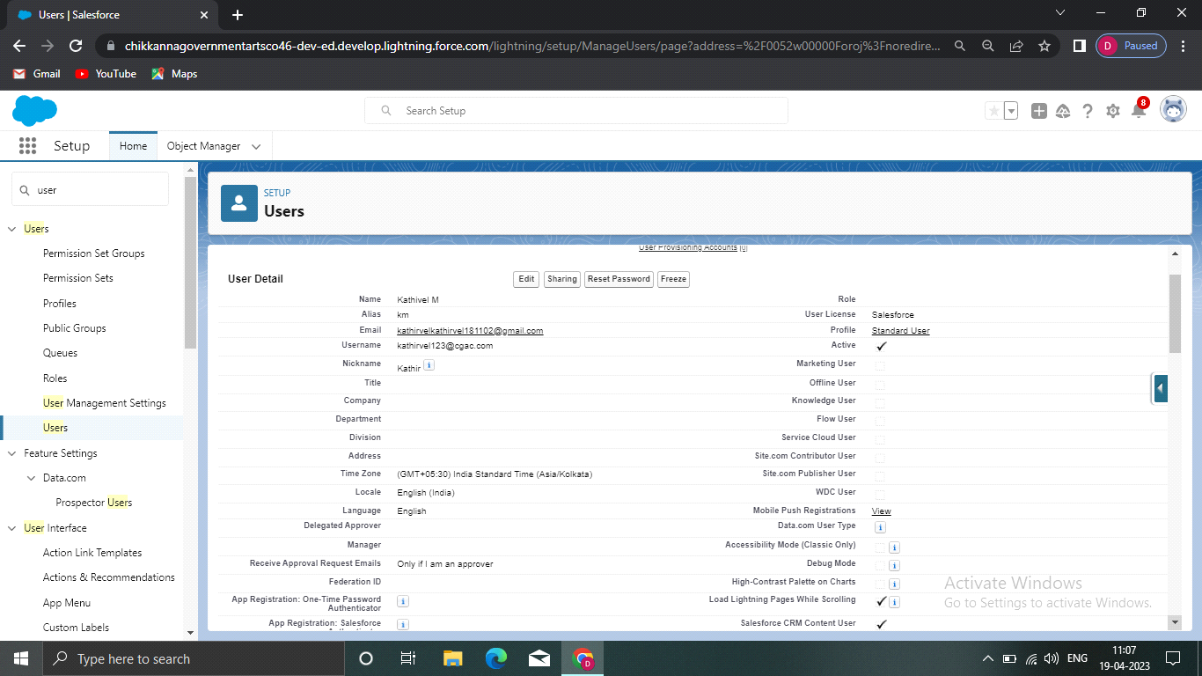

**OWD**

1) Navigate to setup in quick find search bar

2) Type sharing settings and you will navigate to the sharing settings page.

3) Go down to the page and select owd.

4) And click edit on the owd.

5) Navigate to the bottom of the page and select the passport object.

6) And change the default external access to public/Read/write.

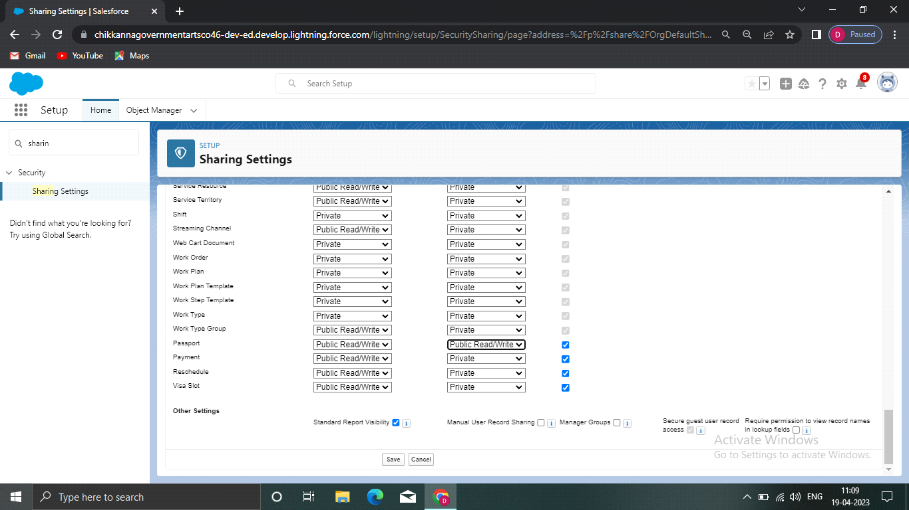

**Reports**

1) Click on the app launcher and search for reports

2) And select a new report, for the record type category select other reports.

3) Select passport with visa slots for the report type name.

4) Select the start button to create a new report.

5) At the left side of the report you can find an outline pane.

6) In the group rows select location.

7) In the group columns select passport:passport number to display.

8) And in columns select visa slot number

9) Now navigate to the filter pane available next to the outline pane and ensure in the show me

section all passports is selected.

10) And in the passport created date select all time.

11) And give the label name Passports with visa locations.

12) Click on save and run for saving the report.

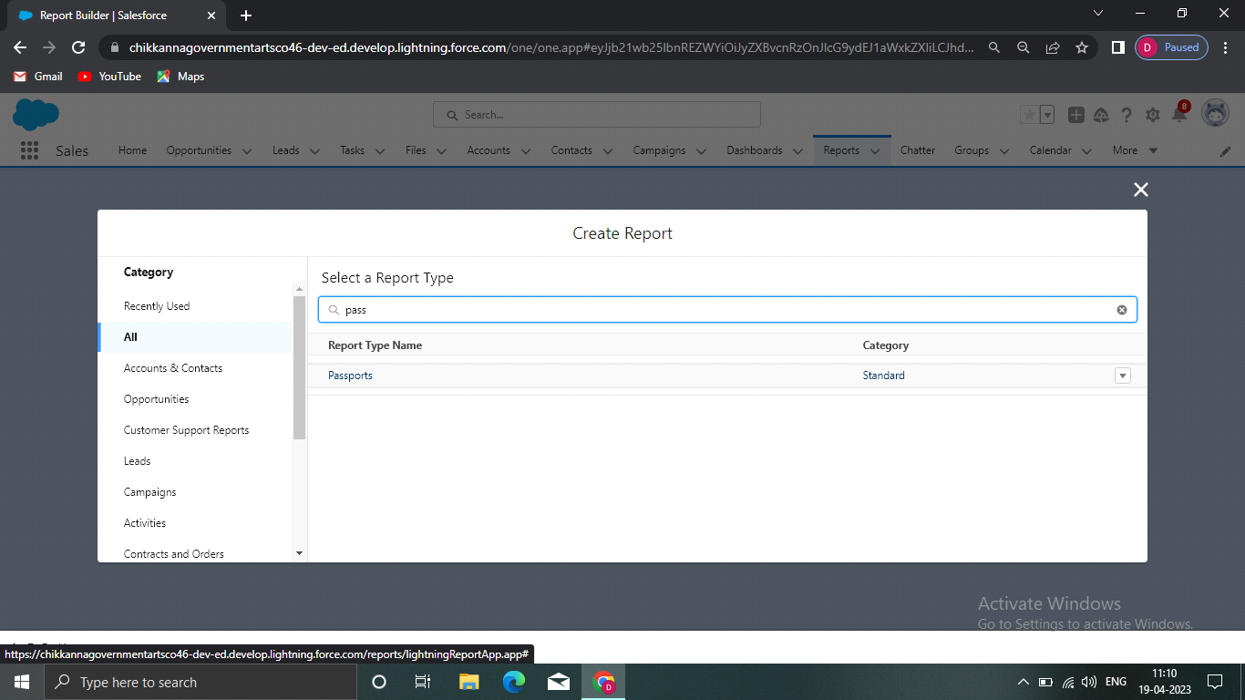

**Dashboard**

1) Click on the app launcher and search for dashboards.

2) Select the new dashboard option.

3) Name the dashboard has a Passport with visa locations

4) And select create option.

5) Now click on Add component and for report select passport with locations.

6) Select the donut chart in display as section.

7) Ensure that value is record count and sliced by locations.

8) Leave the default values.

9) Click on add.

10) And save the dashboard

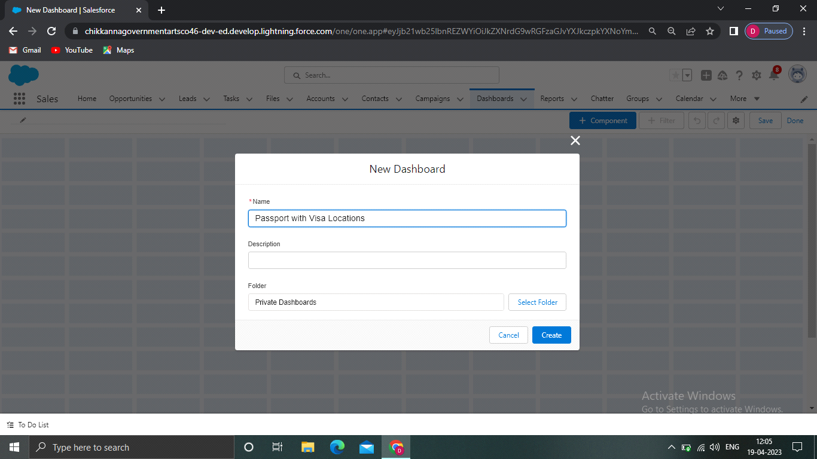

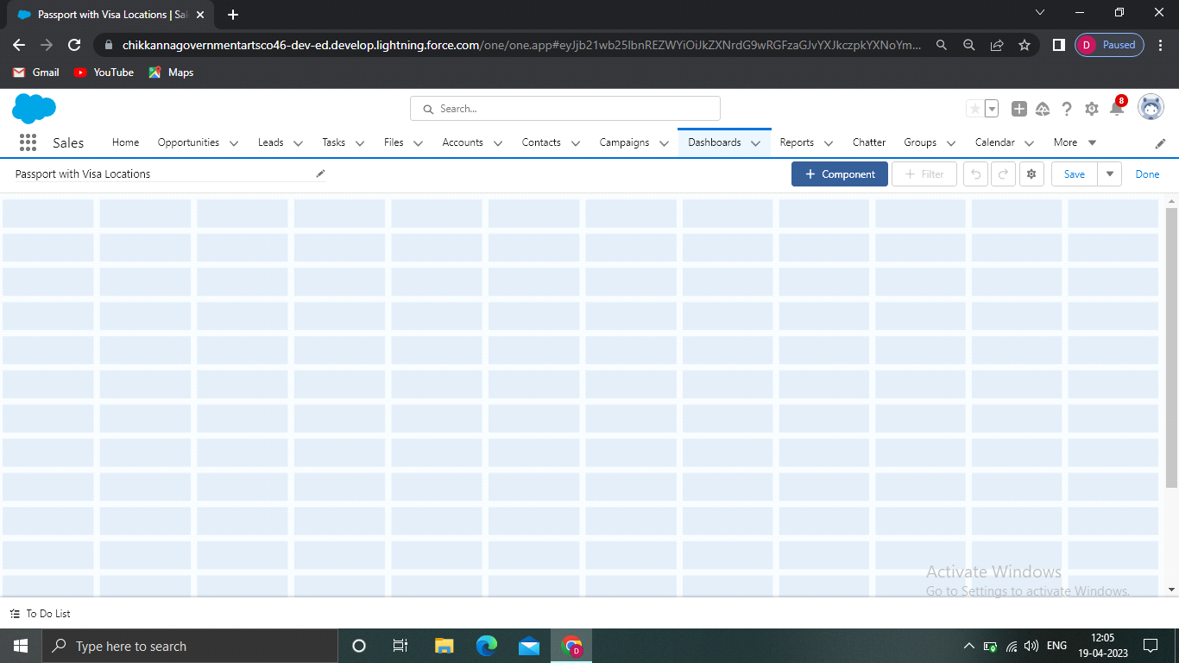

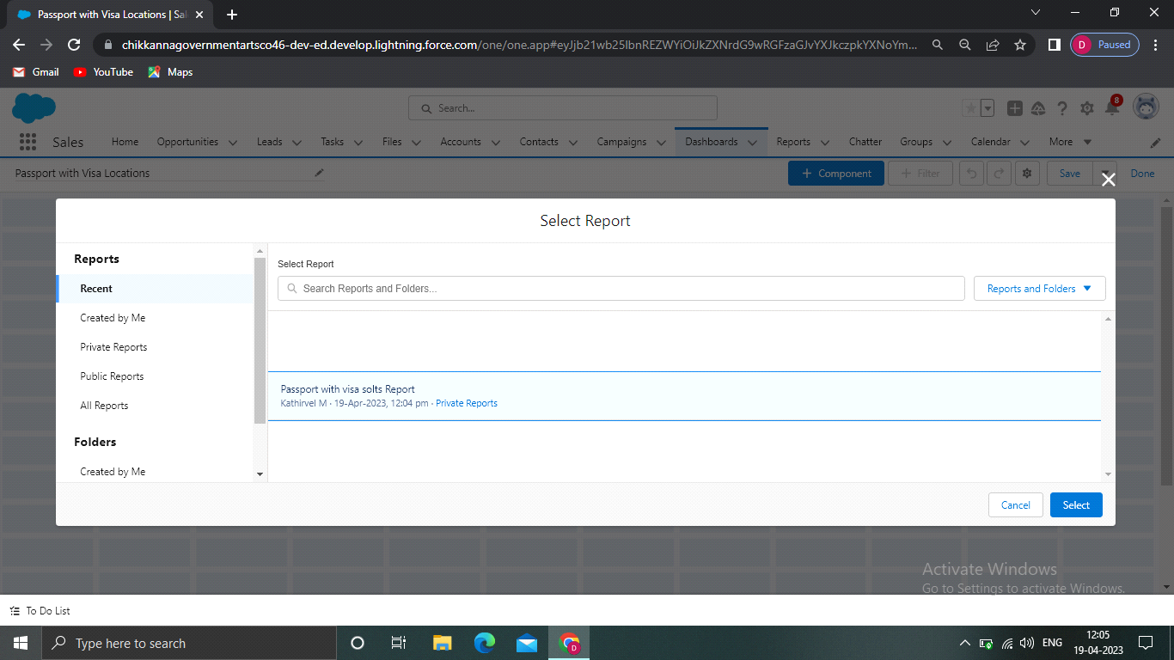

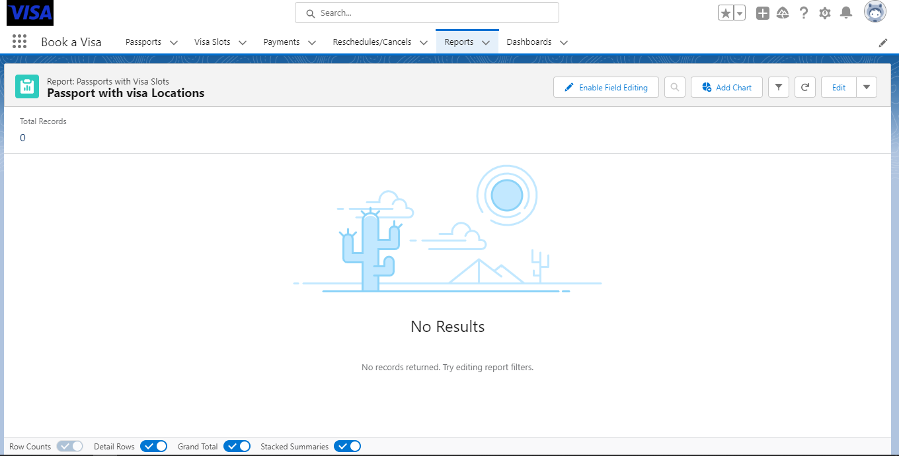

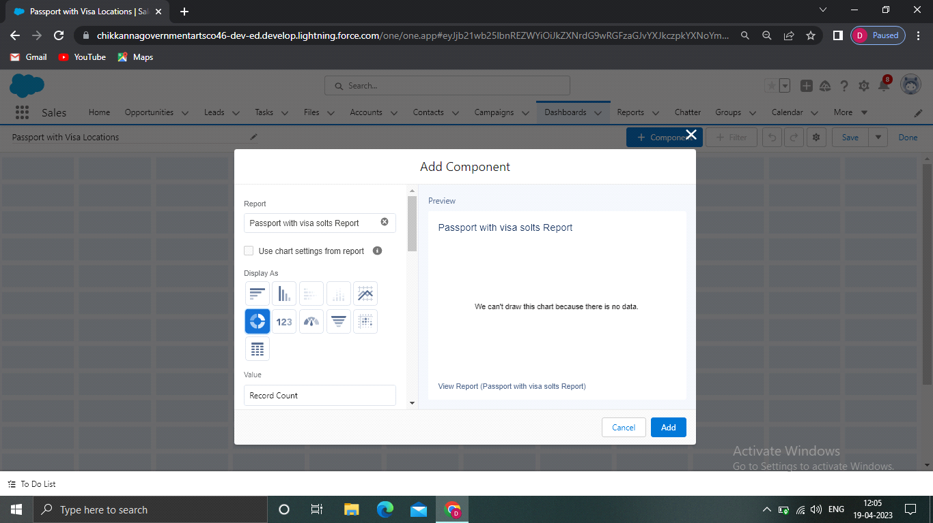

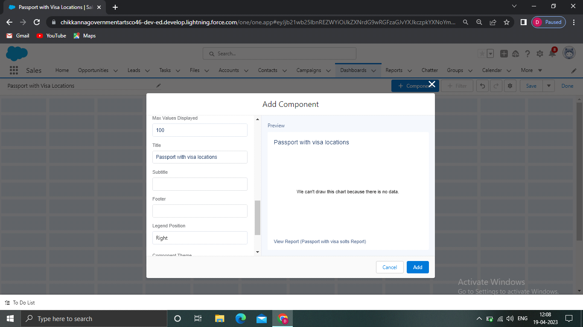

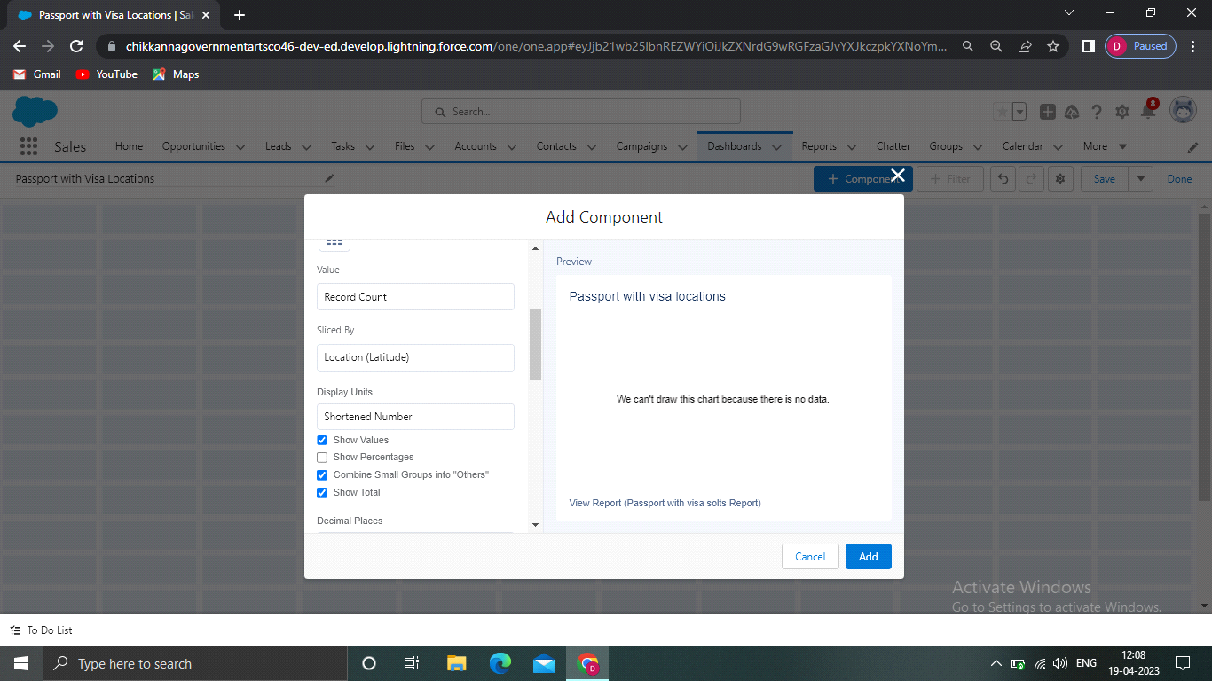

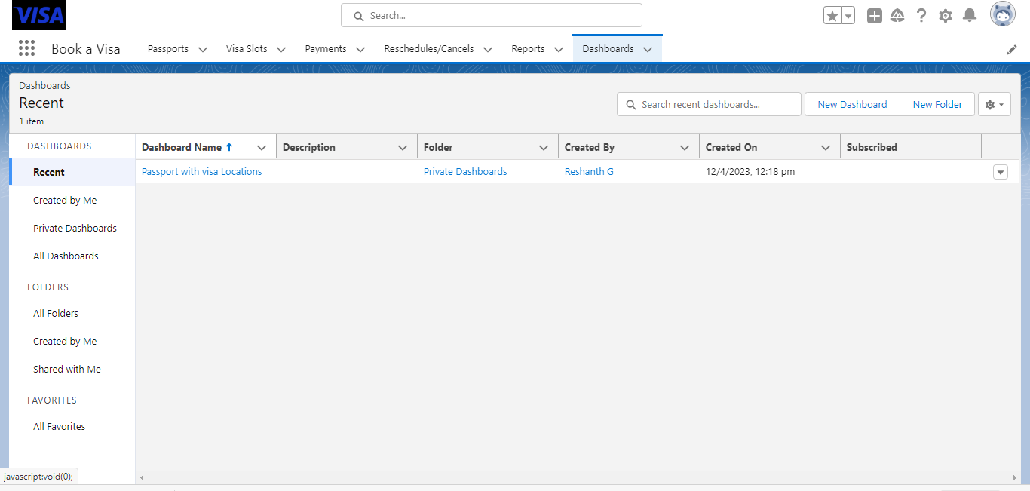

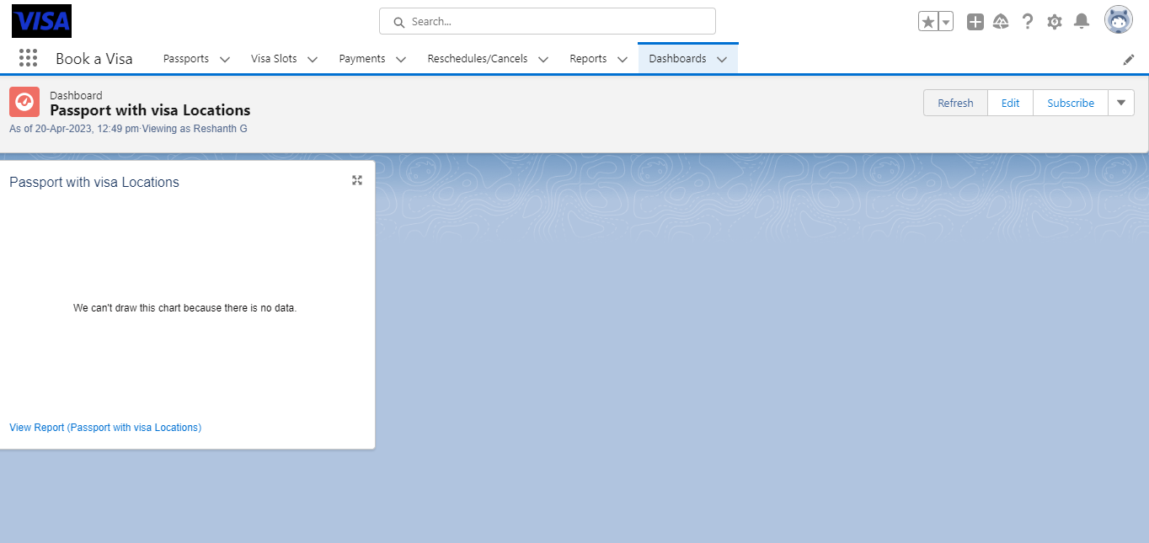

1. **Trailhead Profile Public URL**

**Team Lead(G Reshanth) -**[**https://trailblazer.me/id/reshg7**](https://trailblazer.me/id/reshg7)

**Team Member (K Karthikeyan) -**[**https://trailblazer.me/id/kartk99**](https://trailblazer.me/id/kartk99)

**Team Member (K GokulKrishnan)-** [**https://trailblazer.me/id/gokuk15**](https://trailblazer.me/id/gokuk15)

**Team Member (M Kathirvel) –** [**https://trailblazer.me/id/kathm27**](https://trailblazer.me/id/kathm27)

CRM APPLICATION THAT HELPS TO BOOK A VISA SLOT

**4 ADVANTAGES & DISADVANTAGE:**

Advantages:

Data entry can be automated

An efficient dashboard streamlines sales activities

Potential to add revenue

Allows for easier collaboration.

Disadvantages:

Burdensome data entry

Dependent on proper setup

Focused on the wrong person

Can be costly

**5 APPLICATIONS**

A visa slot management project is a system that is used to track and manage the availability of visa slots, which are appointments that are required for certain visa applications. It might be used by a government agency or a visa processing center to schedule and manage appointments with applicants.

**6 CONCLUSION**

The season of new beginnings and (hopefully) warmer weather. I’ve been looking forward to spring all winter to see if my bees would make it through winter, and I’m happy to report that, so far, they are thriving. I’ve got a few more weeks (read, months) of winter ahead of me here in upstate New York, but this string of warm days has me preparing my bathing suit and summer attire. This month has been exciting, with lots of news coming from Salesforce. In this month’s email, I provide some context on the recent release of Nonprofit Cloud for case and program management, upcoming events from Salesforce and our partners, new(ish) partnerships that we are thrilled about, and a fantastic announcement from Salesforce about free integration user licenses.

**7 FUTURE SCOPE**

The scope of CRM includes a wide range of activities, from managing customer contact information to developing personalized marketing campaigns. In order to be effective, CRM must be tailored to the specific needs of each business. As such, the scope of CRM can vary greatly from one company to the next.Companies will be able to pivot to meet the changing needs and trends driven by customer expectations. Customers expect organizations to know a lot about them and expect to have conversations.

**\*\*\*\*\*Thank You\*\*\*\*\***